|  |
| --- |
| University College London (UCL) |
| Replicating & Studying the Acoustophoretic Board |
| Multi-Sensory Devices Lab |

|  |
| --- |
| Ben Kazemi  1-30-2023 |

Table of Contents

1 Preamble 4

2 Introduction to the PCBs 5

2.1 Controller board 7

2.1.1 Inputs and Outputs 7

2.1.2 Jumpers 7

2.2 Array board 8

2.3 Coupling Orientation 10

2.4 Block Diagram 11

3 Altium Design 1

3.1 Controller board Files 1

3.2 Array board Files 5

4 Gerber files 12

5 Assembly 13

5.1 Bill of Materials *(BOM)* 13

5.2 Controller board 14

5.3 Array board 23

5.3.1 Header Orientation 25

5.3.2 Soldering the SMT components 25

5.3.3 Seating and soldering the transducers 30

5.3.4 Testing 37

5.3.5 Using a thermal camera to test the board 41

6 Calibration 42

6.1 Identifications 42

6.2 How to calibrate the Array board 42

7 Interfacing the Dual Setup 43

7.1 Dual Setup Block Diagram 44

8 Building a dual board case: Overview 45

9 Case: Bill of Materials 45

10 Laser cutter files 46

10.1 DXF format 46

11 Abstract Build 47

11.1 Top Hierarchy Assembly 47

11.2 Top Box Assembly 48

11.3 Bottom Box Assembly 49

11.4 Side Brace Assembly 50

11.5 Complete View 51

12 Cutting the top and bottom boxes 52

12.1 Step 1: Cutting 52

12.2 Step 2: Top Box 52

1.1 Step 3: Bottom Box 54

12.3 Captive Nuts 57

12.4 Bottom Cover 59

12.5 Left Side Bracer 61

12.6 Right Side Bracer 62

13 Adding the Electronics 63

13.1.1 Coupling the Electronics 63

13.1.2 Bottom Box 64

13.1.3 Top Box 66

14 Completed Assembly 67

15 Identifying the Controller Board (Formerly *Daughterboard*) 68

15.1 Quick Glance of Controllers 68

15.2 Controller Board Change Log 69

16 Close-Up View of the Controller Board Revisions 71

16.1 Rev 1 71

16.2 Rev 2 72

16.3 Rev 3 73

16.4 Rev 4 74

17 Array Board Identification (formerly *Motherboard*) 75

17.1 Quick Glance at Array Board 75

17.2 Controller Board Change Log 76

17.2.1 Rev 1 77

17.3 Rev 2 79

17.4 Rev 3 81

# Preamble

As of 2022, we changed the names:

‘Motherboard’ to ‘Array board’, and

‘Daughterboard’ to ‘Control board’.

Effort has been made to edit the documentation to reflect this, however it’d be useful to remember this naming convention as most of our hardware in circulation uses the deprecated naming convention.

To aid the user, we have a chapter towards the end of this document named ‘Identifying our hardware by revisions’, it helps the user identify our main electronics revisions as there are small differences.

Similarly, the case designs have gone through multiple iterations and versions to fit user’s needs, so the photos in this document will not necessarily reflect the hardware that you have. This should not pose a problem, as the modular case design iterations and versions are mechanically like each other.

A guide is in this document that shows the user how to build a standard dual board case.

For our old large cases which fit Revision 1 array boards are the document ‘PRB Case Construction guide V3’.

All guides should be in the ‘Guides’ folder.

This document will refer to various files that can be found in the aptly named folders:

Electronics 🡪 Transducer Boards 🡪 Array (or Controller, or ‘Older versions’ if you have an older board)).

*References in the first few chapters are to our old Revision 1 board files, however the newer files are similar in structure and naming.*

# Introduction to the PCBs

There are two PCBs associated with the *Acoustophoretic Board* setup, the *Controller board,* and the *Array board*.

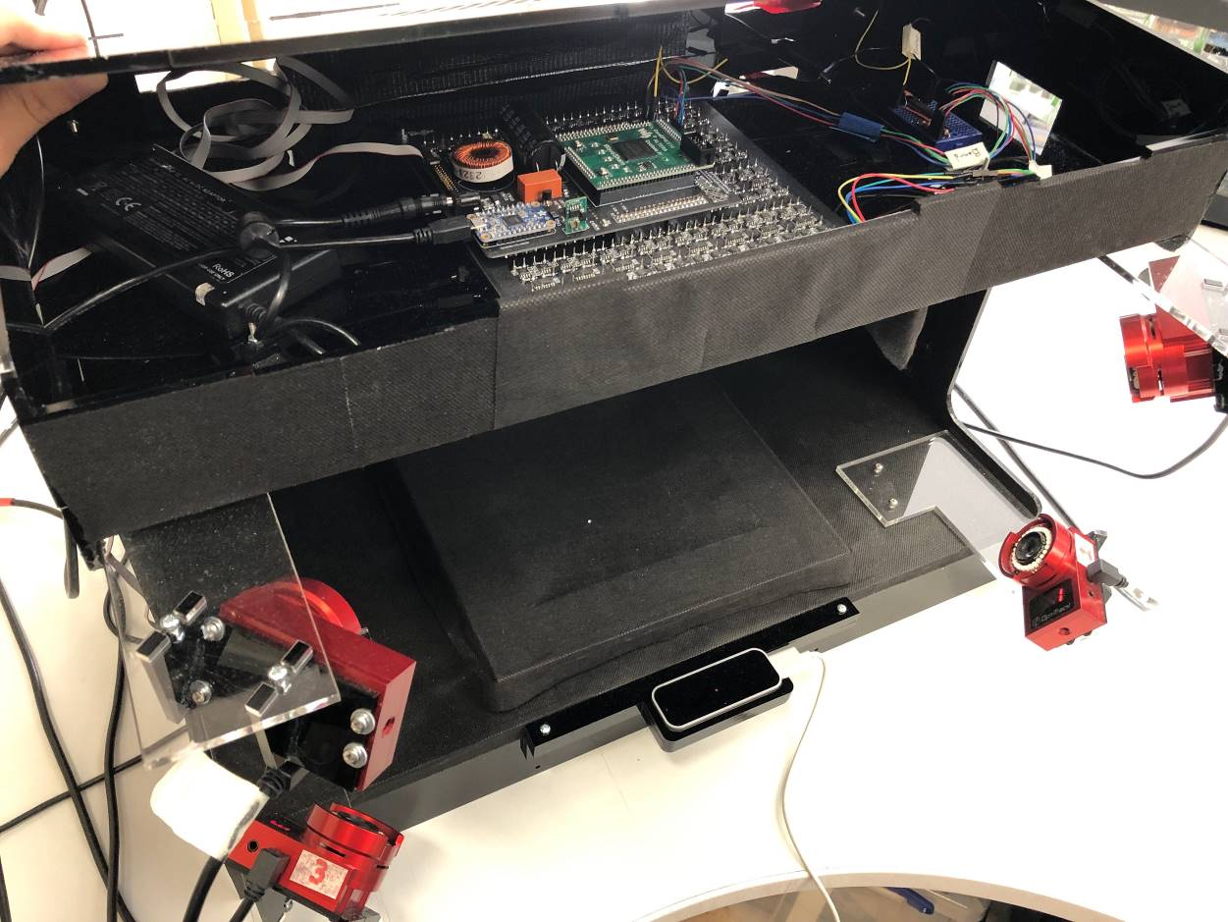

Figure 1 final dual-board setup

In the image above, you can see two sets of both PCBs with both speaker arrays facing each other with the working space between them, this is called a dual board setup.

This image shows one of our earliest cases from 2018. We have a few new versions as you can see in the next page. The images show our scaled four board case utilising 1024 transducers, various dual board setups, and a gimble version of a dual setup.

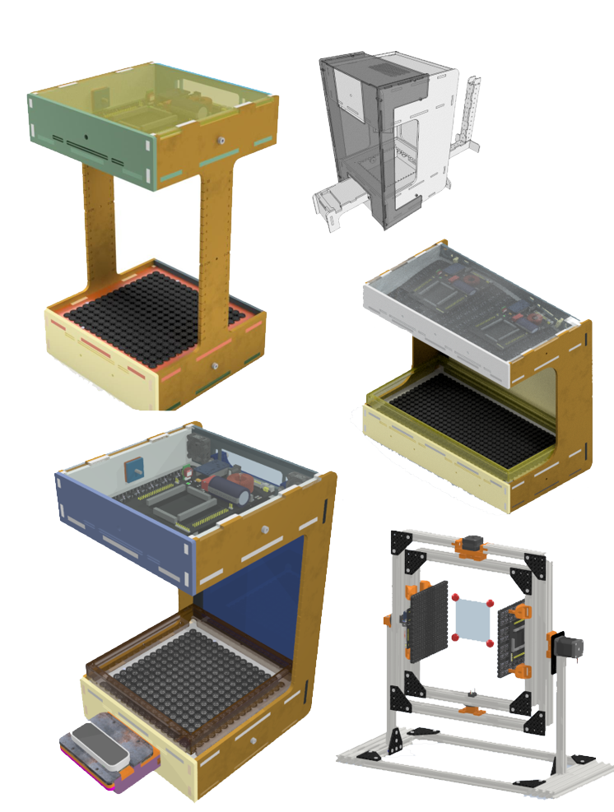

Figure Selection of cases

## Controller board

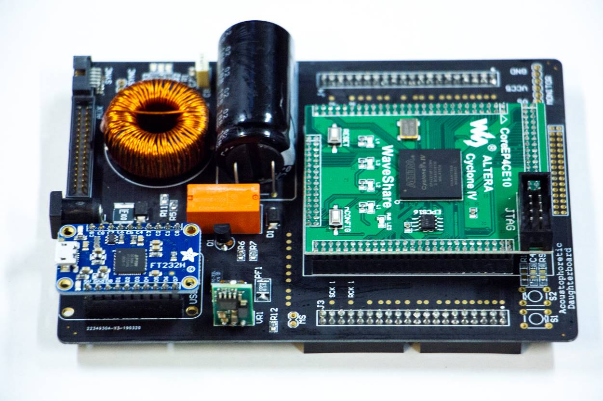

Figure 3 Standalone Controller board

The controller board encapsulates power-conditioning from a 18-20 Volt centre positive polarity input. The heart of the board is an EP4CE10 Altera Cyclone IV FPGA. It regulates other voltages for on-board peripherals, each with a dedicated polyfuse. A software controllable relay exists to toggle power to the transducer amplifiers. Two programmable tactile momentary switches are on-board and connected to GPIOs on the FPGA for debugging purposes along with three state LEDs: 5V VCC generation, Power Input, and conditioning power to the array board. Newer controller boards omit the tactile buttons.

### Inputs and Outputs

* USB Header for communication utilising an Adafruit FT232H breakout board;
* 20 Volt barrel jack;
* Auxiliary header (20 V, 5 V, Ground, 26 IOs);
* Synchronisation header (Ground, 9 IOs);
* Voltage pins for probing the voltage generation under load; and,
* J3 and J4 are coupling headers for the Array board, they carry 5 V, 20 V, Ground, and data.

### Jumpers

All jumpers on the controller board only affect the functionality when used in a dual board setup.

* *Master Select* (MS), (in later revisions this is called SS for Slave Select as this describes the behaviour that was developed later better since the jumper turns that controller into a slave), bridge with a jumper to set as slave. Open the bridge to set the Controller board as amaster. This is used to send synchronisation data from the master controller board to the slave controller board; **you use a ‘pin header jumper’ to connect these two wires if you want the controller to be a slave – in any configuration of boards, you must have exactly one master, so all other controllers should have this jumper set.**
* *Vin2SYNC* (Voltage input through Synchronisation connector). Bridging these on two connected Controller board’s carries a conditioned 20 V from one Controller board to the other, note that current versions exhibit a 1 V discrepancy between the Controller boards. **Do not set this unless you know what you are doing, these should be UNSET (no jumper) by default.**
* Newer boards have what may look like jumper pins under header ‘J8’, **THESE MUST NOT BE SHORTED.** They are exclusively used for debugging and bypassing various stages of the power conditioning.

## Array board

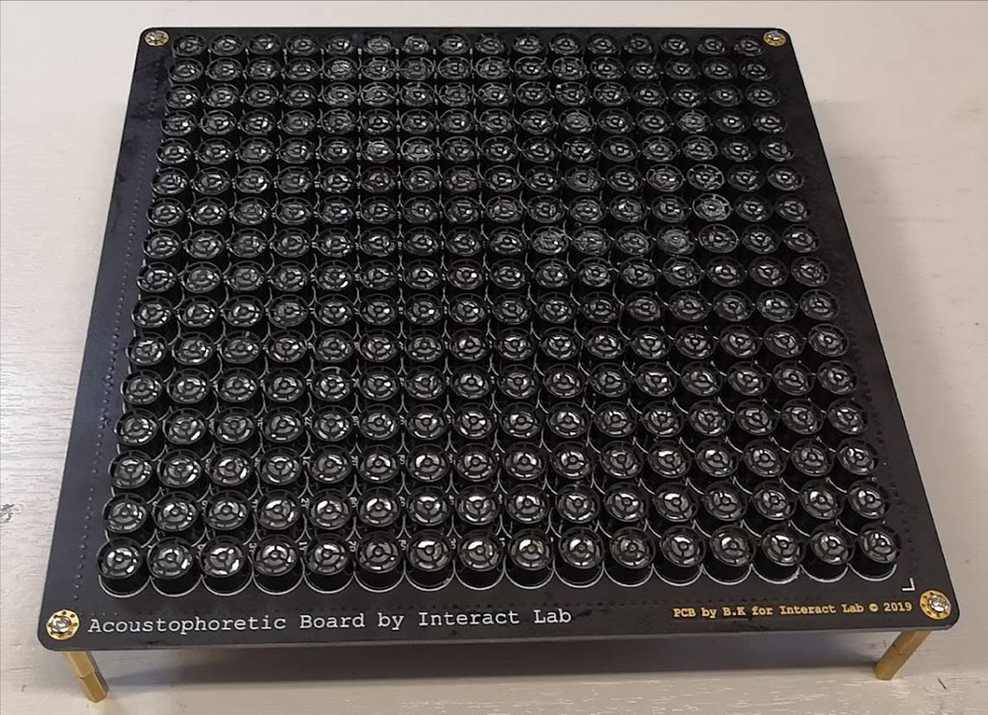

Figure 4 array board

This PCB houses all 256 ultrasound transducers. Its entire IO and power inputs are through the two coupling sockets that mate with the Controller board. On-board we have the amplifier ICs, shift registers and associated bypass capacitors. We also have four mounting holes in each corner, these can be used how the end-user desires, but importantly are key during assembly.

On newer boards, the mounting holes are castellated holes on the four edges, two for each side. Furthermore, there are four internal holes available to use.

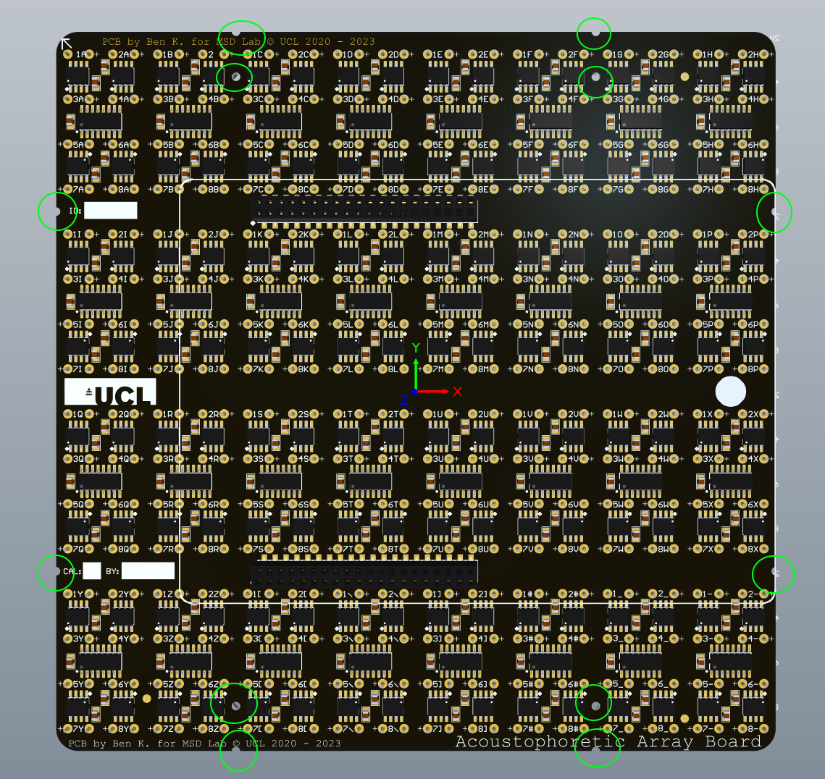

Figure 5 12 accessible holes available for mounting

## Coupling Orientation

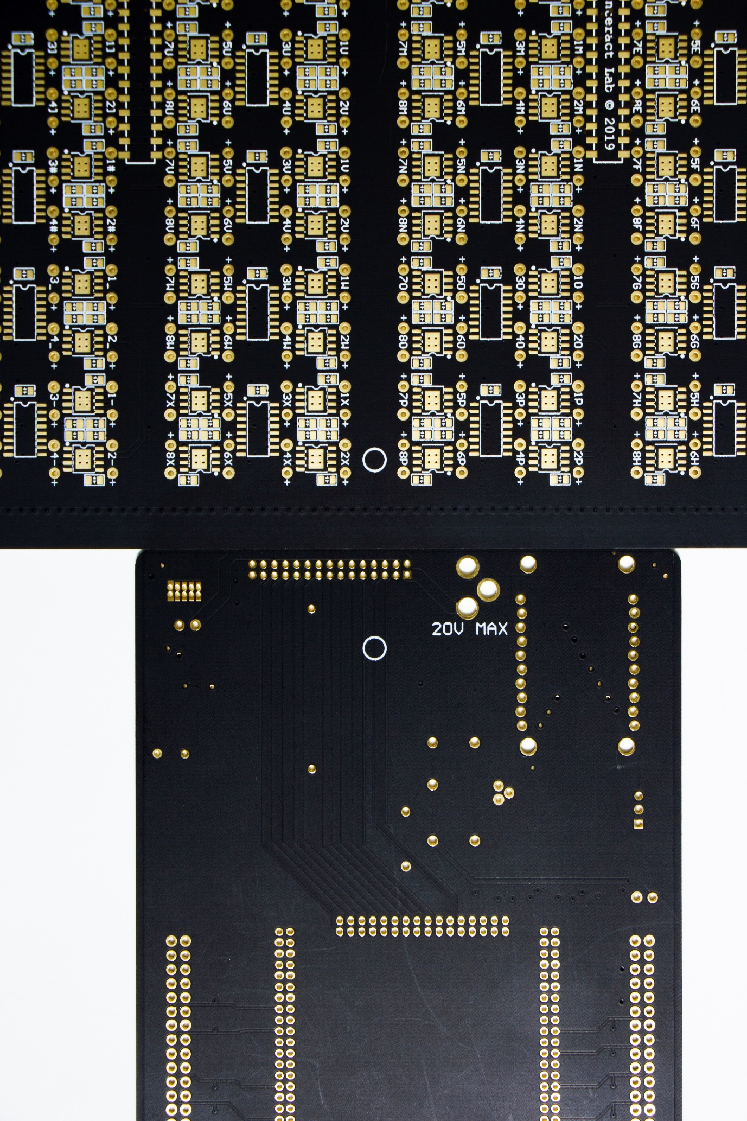

Figure 6 Highlighted are the orientation stamps. The stamp is on the bottom side of the Controller board and must directly face the stamp on the top side of the Array board.

On the rear of the Array board we have a small circle printed at the midpoint of one of the edges. It is used as an orientation guide during mating as the same circle exists on the rear of the Controller board. These two Circles should face each other. Later assemblies utilise headers that only allow one orientation, including a lock that asserts all coupling headers to be connected to the socket. The previous figure also shows an outline in the shape of the controller board to further aid the user in making sure the orientation is correct. **Incorrect orientation will damage the electronics.**

## Block Diagram

Figure shows a block diagram of the functionality for both PCBs and how they interface.

# Altium Design

In the root folder are two zip files aptly named for the Altium design files. Inside both zips are a number of .SchDoc (schematic) files, one .PcbDoc (PCB Layout) file for each PCB. Opening each file in Altium reveals the entire schematic and PCB layout design files. Both PCBs are six-layers.

## Controller board Files

The Controller board has two schematic sheets and one PCB document. ‘Daughterboard_Power’ shows the connections for the voltage generation and conditioning segments, including various peripherals. ‘Daughterboard_Headers’ displays the definitions for the FPGA connections, Connections to the mating headers, headers to the on-board USB controller, and Aux and Sync header connections.

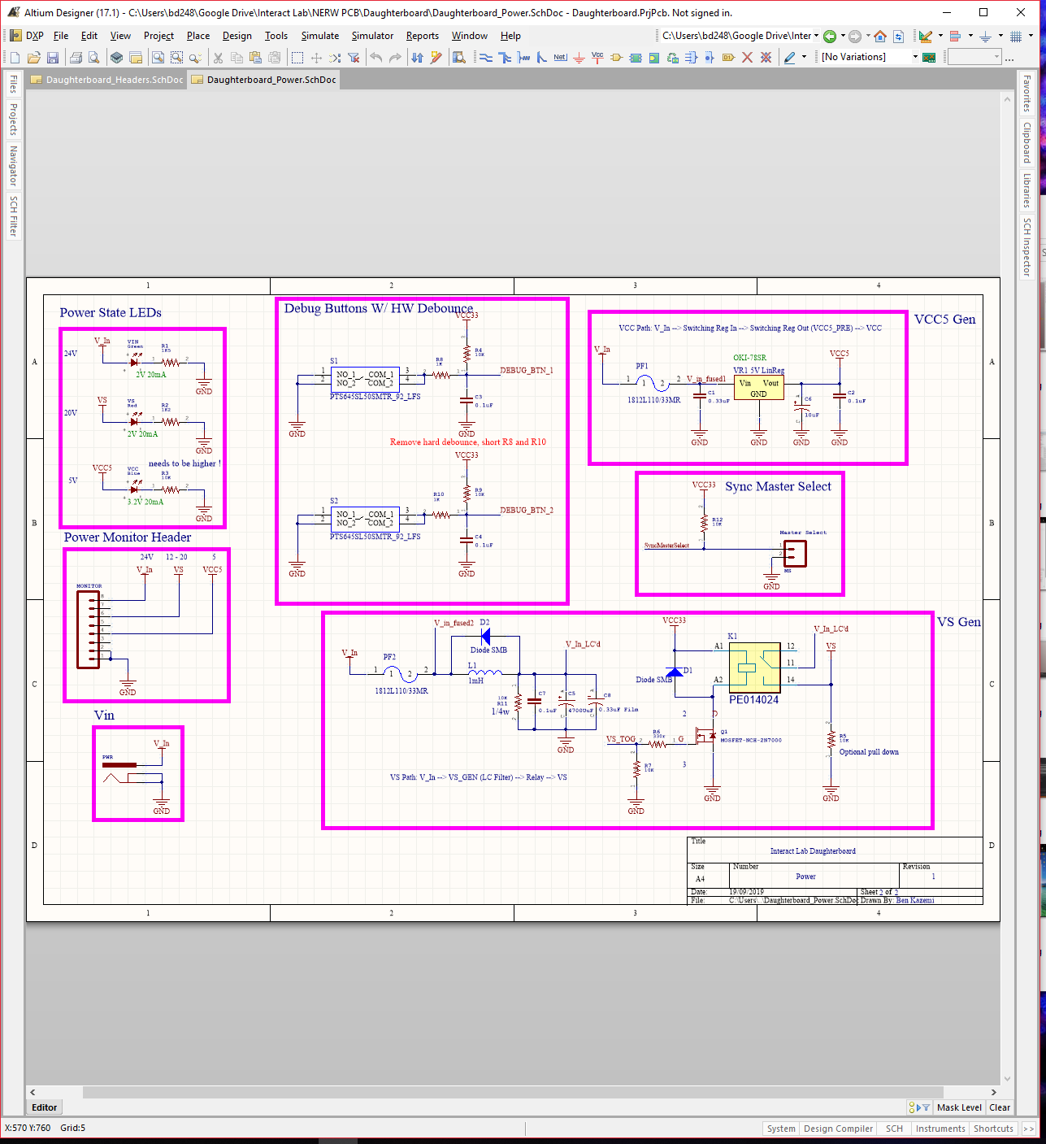

Figure 8 Rev 1 Schematic for the power stage

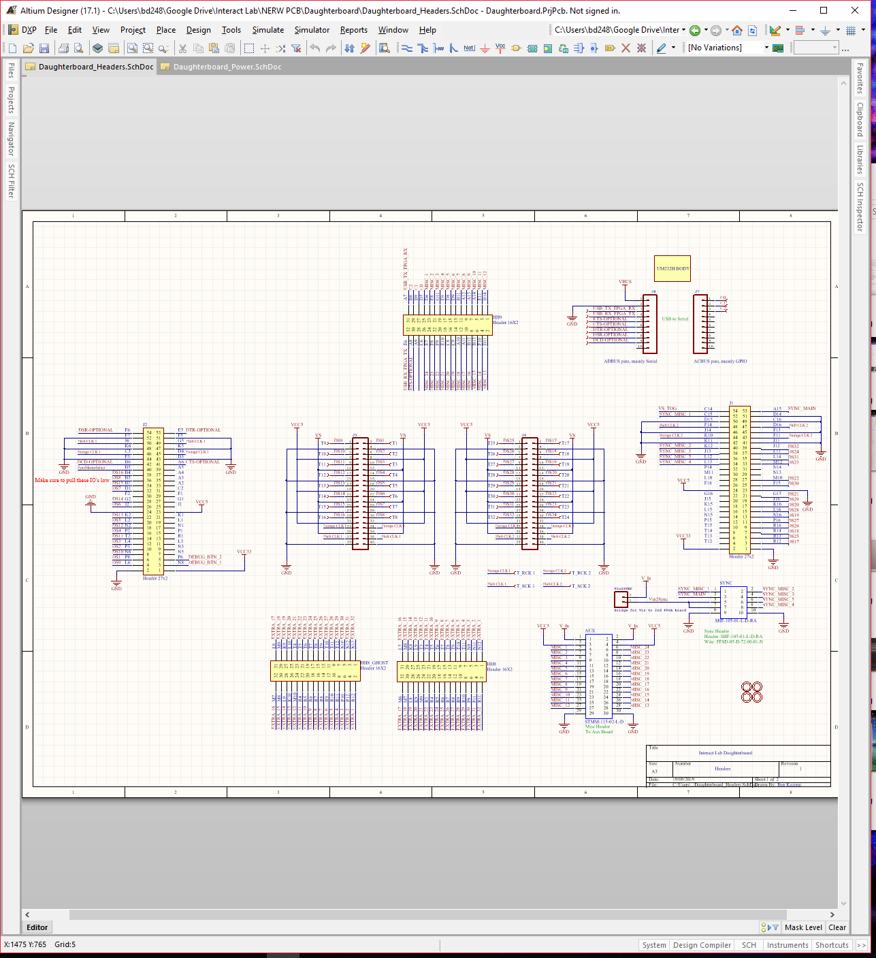

Figure 9 Rev 1 Schematic for the headers

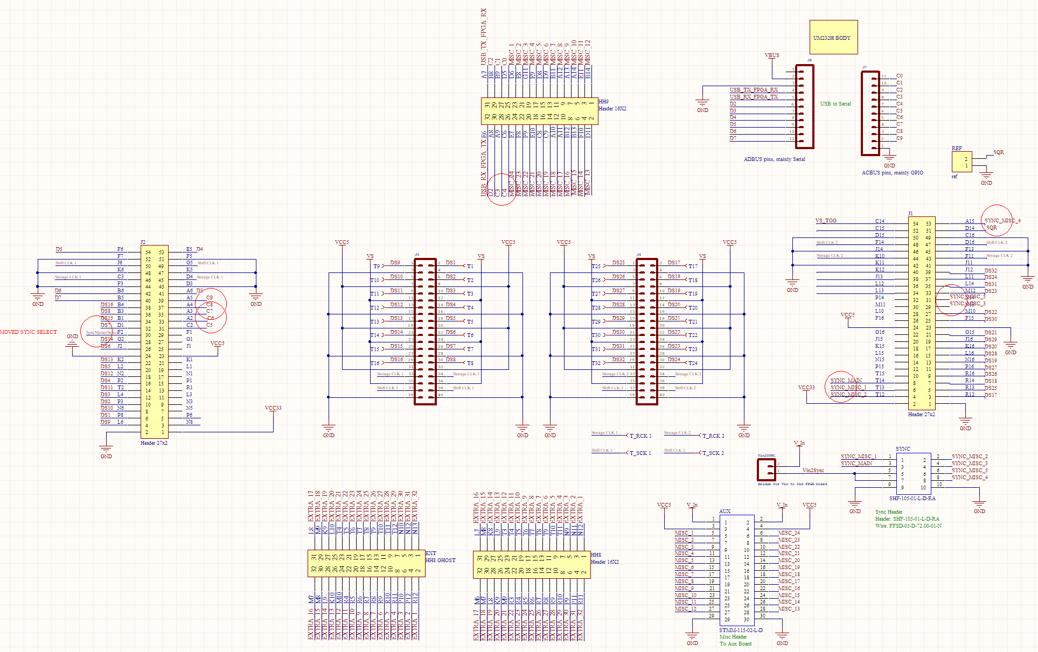

Figure 10 Rev 2

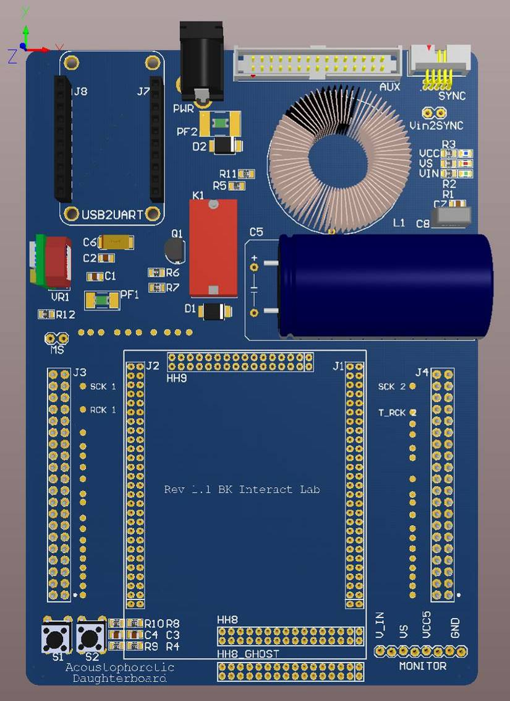

Figure 11 Rev 1 3D render of the Controller board with modelled parts. This is an original revision (rev 1) from 2018, please consult the additional documentation to compare the versions.

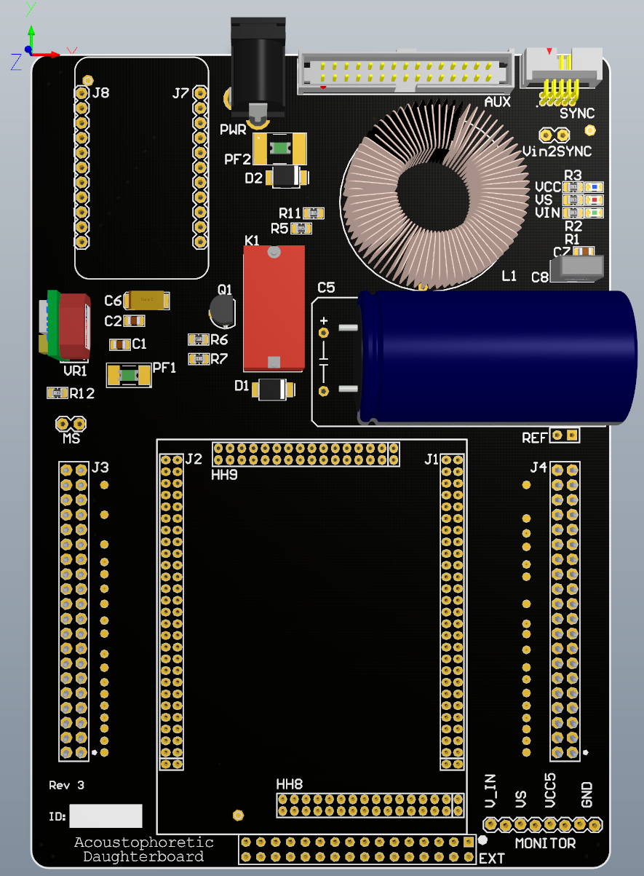

Figure 12 Rev 3 shows one of the newer revisions, we are currently at revision 4.4 in 2023.

## Array board Files

The Array board has three schematic sheets in a hierarchical format, with ‘Motherboard_Top’ as the parent of 32 ‘ShiftAmplifyEmit’ schematic sheets, that communicate with one ‘Headers’ schematic sheet. The schematic sheet ‘Motherboard_Top’ only defines the structure and replication of the remaining two sheets. ‘Headers’ defines the pin mapping of the two on-board headers. ‘ShiftAmplifyEmit’ defines the shift register and MOSFET driver IC connections. ‘Motherboard_PCB’ is the complete PCB layout file.

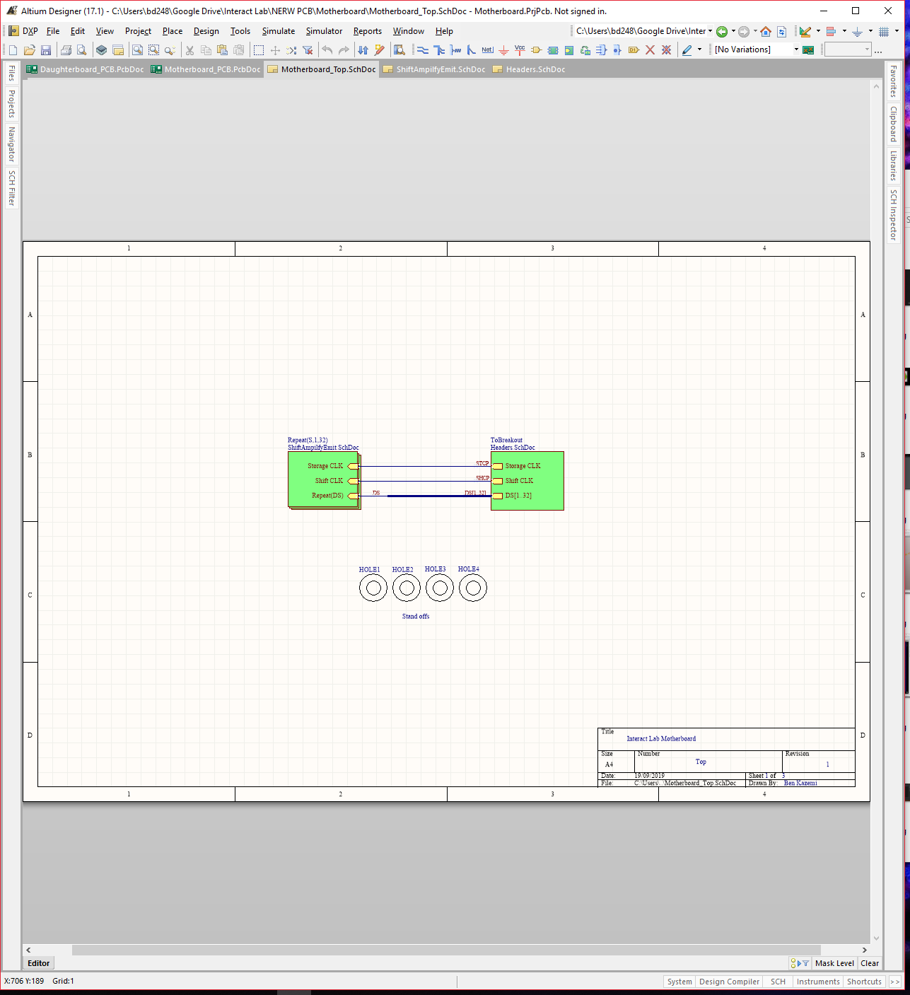

Figure 13 Rev 1 array board top schematic defining the design hierarchy.

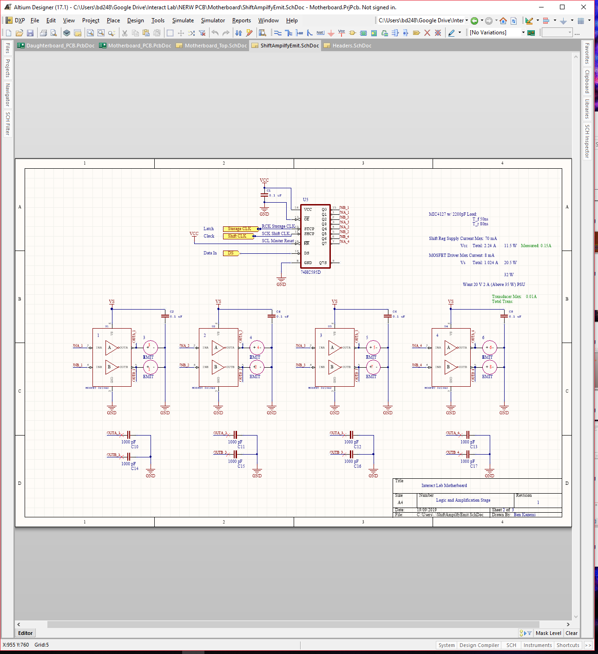

Figure 14 Rev 1 This schematic is copied 32 times. It defines the design for the shift register blocks, and how they interface to four MOSFET drivers and their transducers.

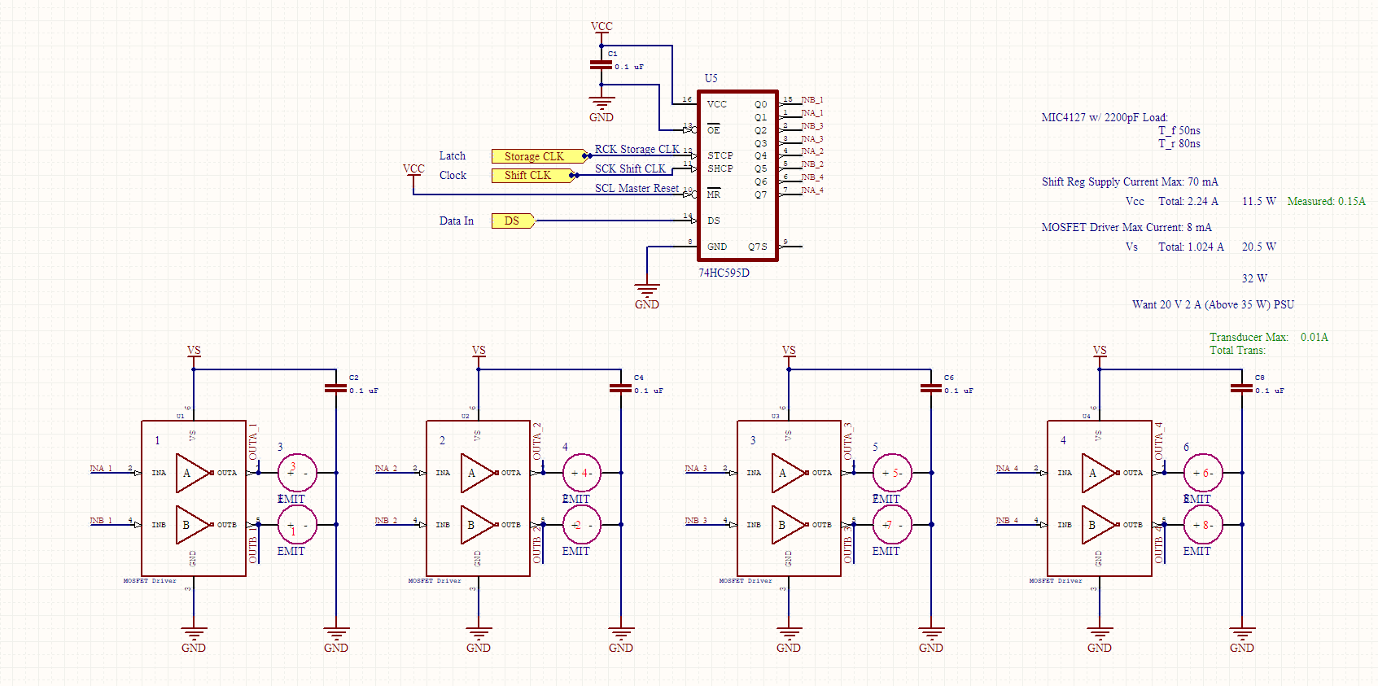

Figure 15 Rev 2

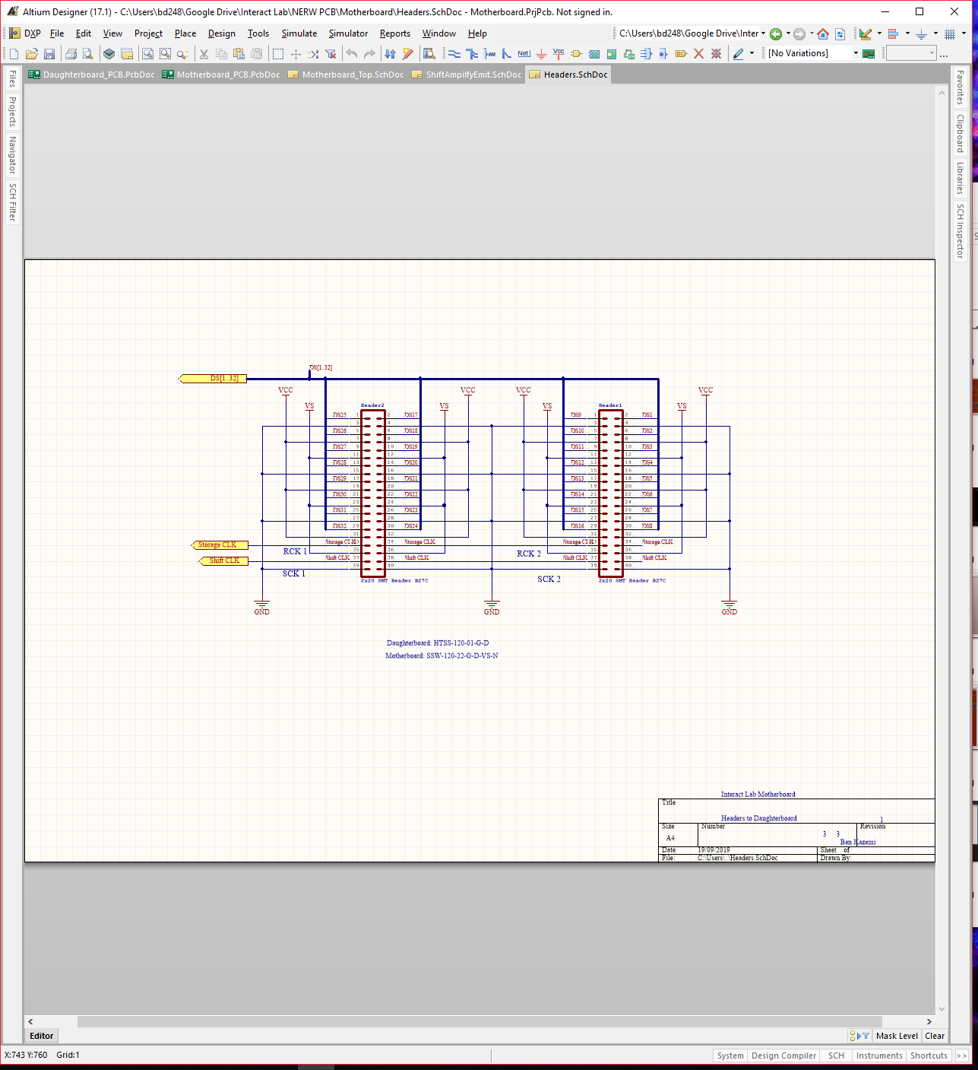

Figure 16 Rev 1 array board headers.

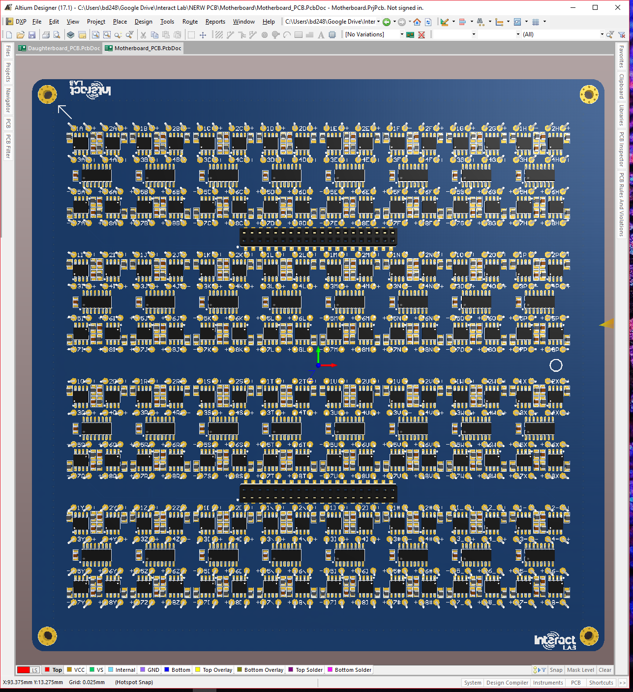

Figure 17 Rev 1 Underside 3D render of Array board, this along with rev 2 are the only revisions with the thick edges, from rev 3 onwards the edges are cut away.

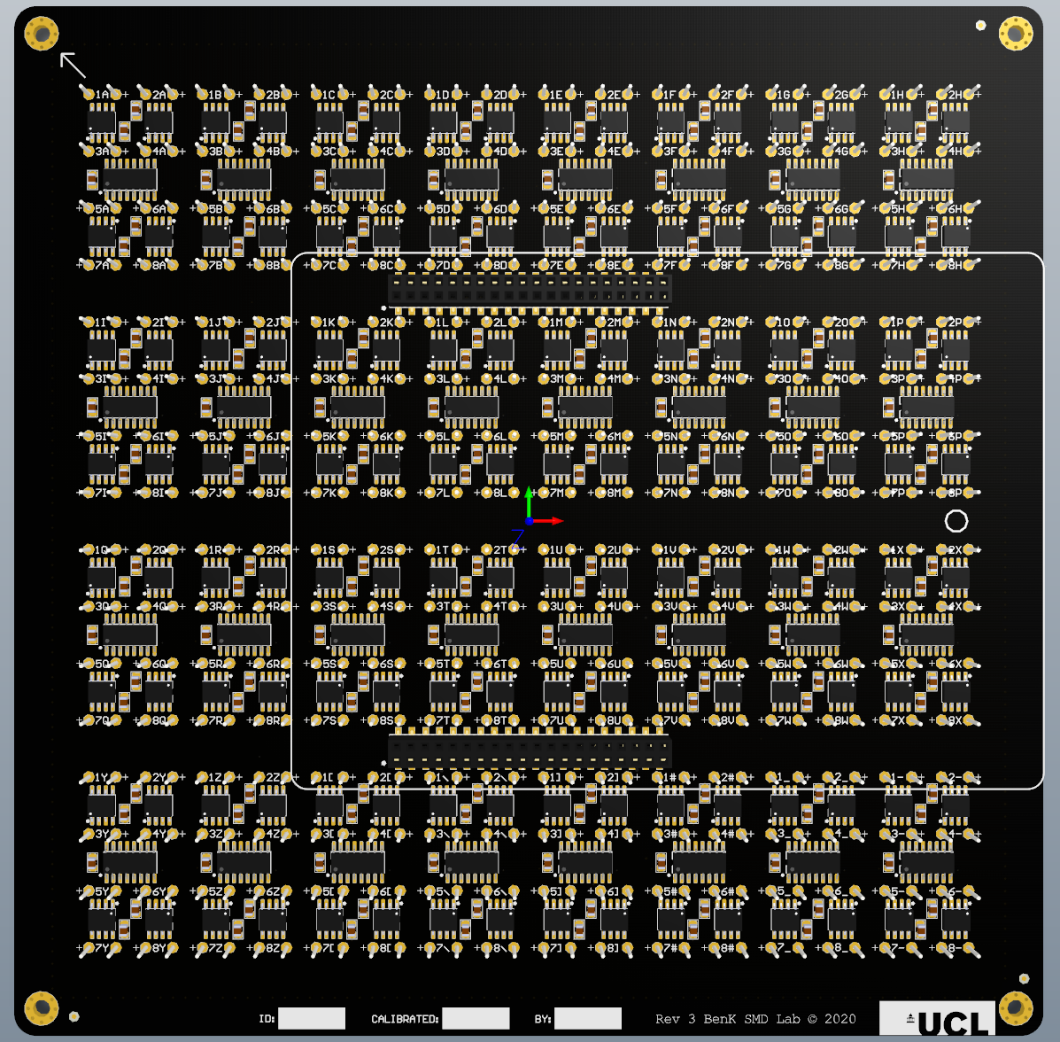

Figure 18 Rev 3

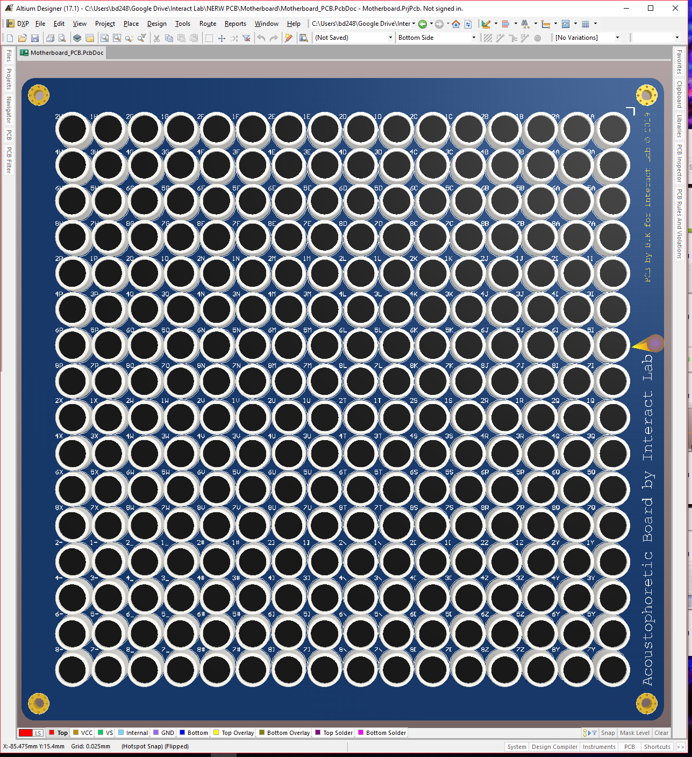

Figure 19 Rev 1 Top side Array board 3D render

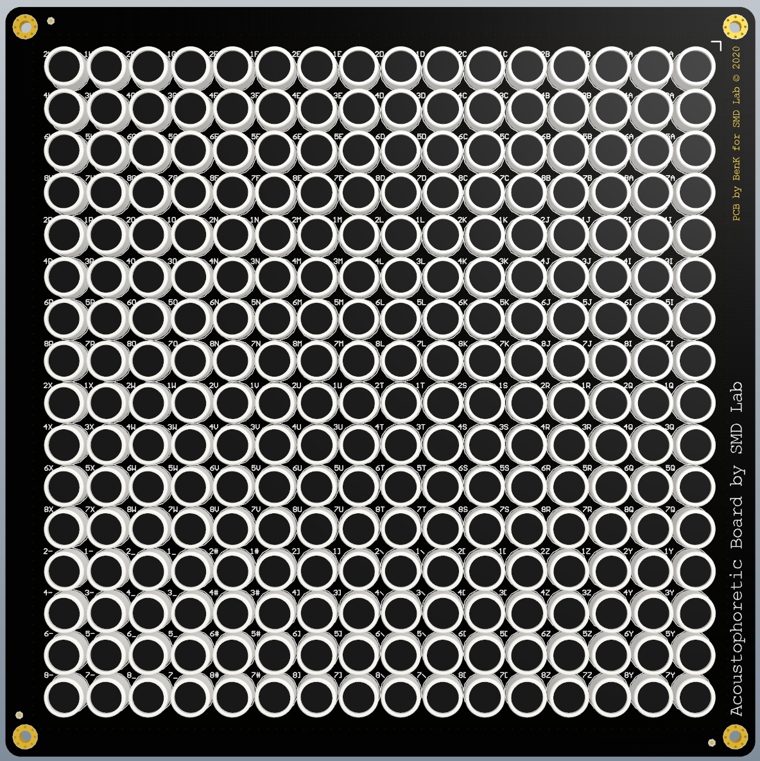

Figure 20 Rev 3

# Gerber files

You can find zips for gerber files inside ‘\Electronics\Transducer Boards\older versions’ that contain the Gerber files for the completed PCB layouts for both boards. These are a file type that fabrication companies will work with (they usually request the entire zip file to be uploaded). We used JLCPCB as they met our specification requirements; both PCBs are six-layers, and we selected a matte black solder mask so the PCB doesn’t stand out in our setup, we also selected an ENIG surface finish which aids in the assembly process. We use a 2 mm PCB for the array board and a 1.2 mm PCB for the controller board.

Most PCB Fab houses accept PcbDOC files, the Altium file for the PCB instead of gerber files, the author suggests using those files if you wish to fabricate more boards instead of exporting gerbers.

The stencil file for both designs are in their respective zip files. They will be necessary for the array board’s assembly if you plan to assemble these boards yourself, though this won’t be for the faint of heart.

Use these files to get a delivery of the stencils and finished PCBs from whichever PCB fab house you prefer.

# Assembly

## Bill of Materials *(BOM)*

Inside the same folder are two excel files, *BOM_Daughterboard* and *BOM_Array board.* These files are the bill of materials for both boards, they have also been used to keep a stock count of the parts so one always knows how many builds are currently possible. These files are also useful for knowing names and part numbers so you can easily source and assemble new PCBs.

## Controller board

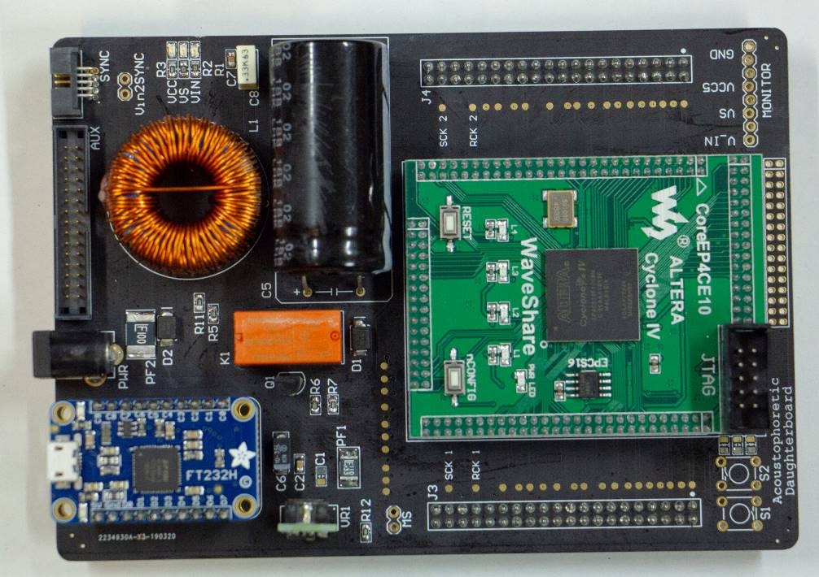

Figure 21 Final Controller board, use this image as a reference source when building your own Controller board

This PCB contains board SMT and THT components. Standard procedure is to solder the smallest components first, that being the SMT components, then on to the larger THT components and headers. The SMT components can be soldered using paste and an oven / hot air gun, or with an iron since the component count is low. After the SMT components comes the headers and sockets, after that the larger components like the voltage regulator and peripherals, then finally the inductor, capacitor, and relay. It is advisable to use either super glue or hot glue to tack the large inductor and capacitor down to the PCB.

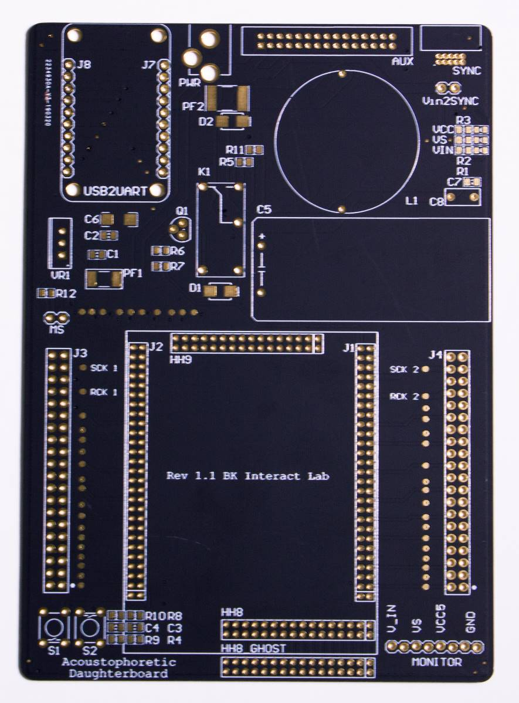

Figure 22 Cleaned bareboard

Pay close attention to not create any undesired shorts between the various solder pads, the pitch of many of the headers are very fine and exhibit small gaps of solder mask between the exposed copper (0.2 mm).

As with any bareboard, we first clean it with *Isopropyl Alcohol* (IPA) by spraying the entire board then wiping the remnants with a kitchen tissue. This is to remove any residual fingerprint oils that may be on the board.

To know which component goes where, we can either use the data in the BOM to cross reference with the designators on the board, though the author prefers to use the Altium files. Open both the schematic and PCB layout files and split the two files vertically. You can then use ‘cross probe mode’ to pick each component in either file, and have it highlighted in the other. The schematic file will show the designator and part numbers, use this to know which part to place.

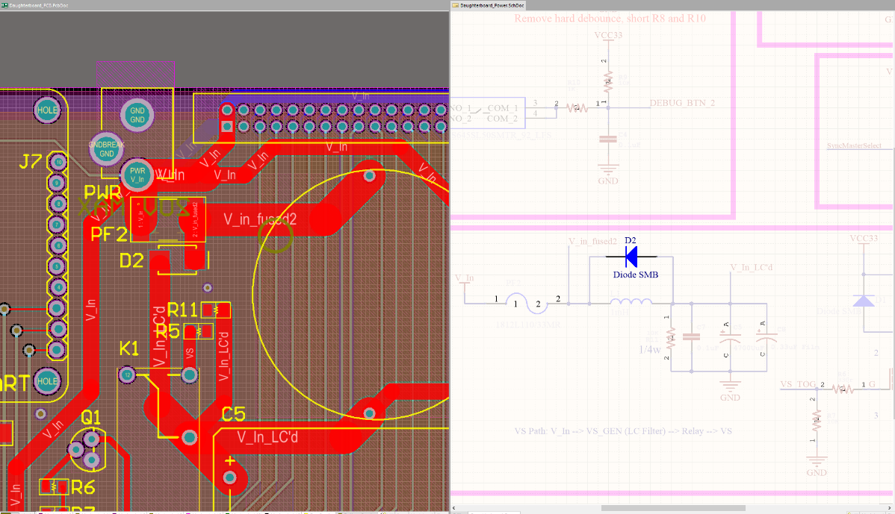

Figure 23 Using cross probe mode select to know which component to place on each pad. Note the highlighted diode.

The screenshot above shows the vertically split view after using cross probe mode to select the component with the designator ‘D2’. The schematic shows the part number for D2; Note the orientation of this polarised component is given by the line on the right side of the right pad in the PCB layout. All polarised components will have their polarity signified on the silkscreen, this polarity is given usually as a line and is to be matched along with the line on the component. If in doubt, check existing boards or the reference photo above. As a unique case, the LEDs polarity is given by the arrow between the pads, match the direction with the arrow under the LED.

There are many ways to assemble a board, but with this Controller board in particular, the simplest is to use an iron to ‘tack’ one of the two pads for each SMD footprint, the idea being to use tweezers to hold and align the SMD component in place while simultaneously melting the previously soldered pad. This way the SMD component stays in place and we can move onto the other components. When all SMD components are tacked, then solder the remaining pads. When assembling the board, pay attention to the *Do Not Include* (DNI) labelled components in the schematic. In this case, they are components for unnecessary functionality.

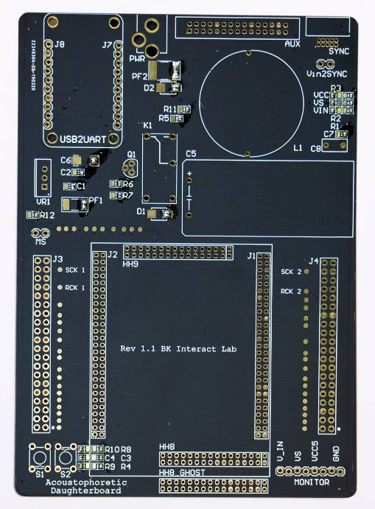

Figure 24 Tacked Controller board. See how each SMD footprint has one pad populated with solder.

Figure Small SMD components soldered first

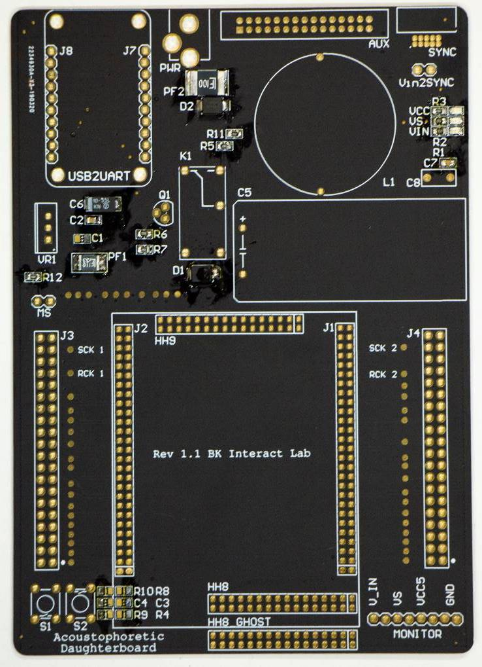

Figure Headers assembled after SMD components

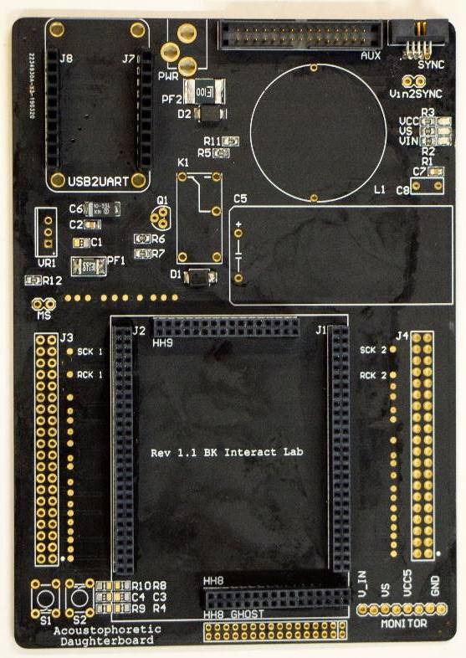

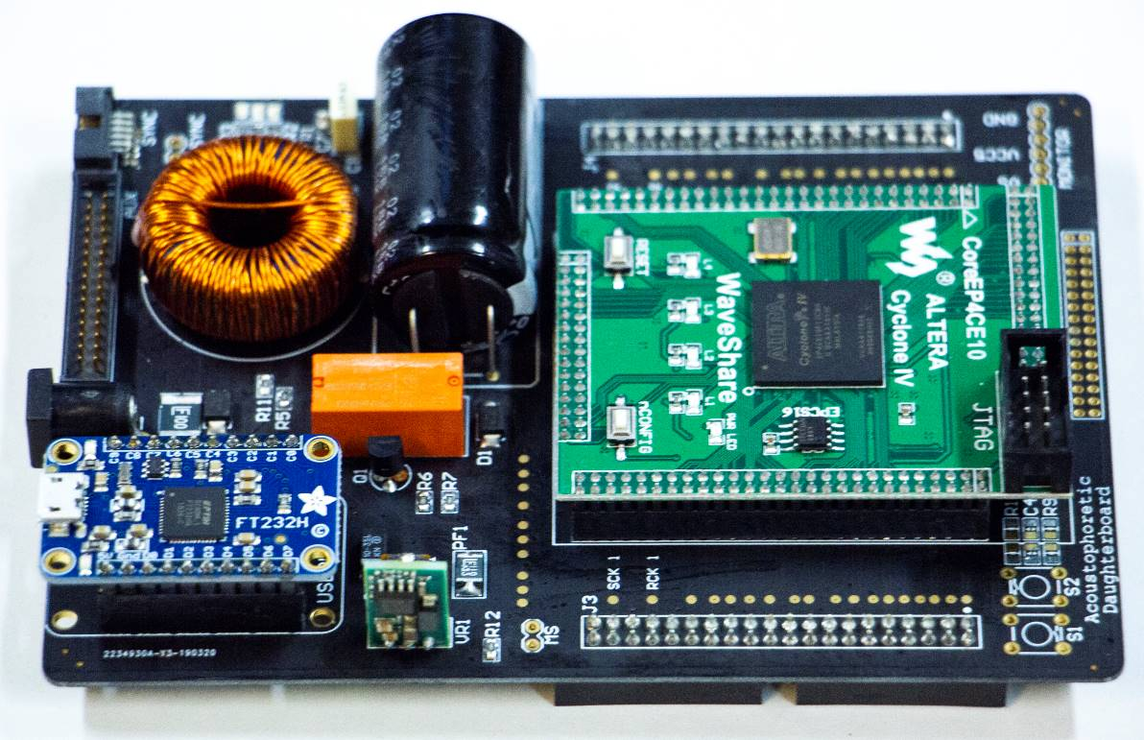

Figure 27 Finally soldering the remaining components

We have no finished assembling the Controller board. Now take a multimeter set on continuity mode, and test three points, between:

1. Ground – VCC5
2. Ground – VS
3. Ground – C_IN

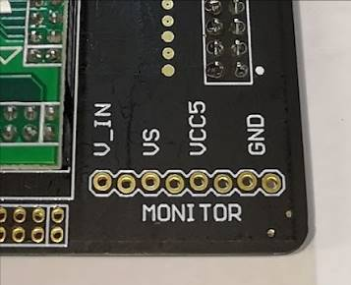



Figure 28 Power Monitor used for testing

The MONITOR port in newer revisions easier to access as they are double row headers, all versions of the controller boards have no connection between each pin, as denoted by the red dots.

Provided there are no shorts, we can be confident that the Controller board has been successfully assembled, and at least will not blow up when we plug it in. There may be issues in your soldering in the design elsewhere outside of the power rails such as one of the data lines, but we will only know once we’ve flashed the FPGA and probed the test pads.

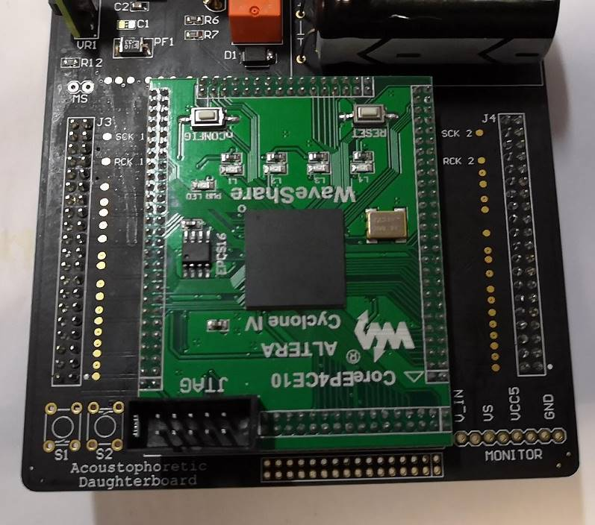

Figure 29 Testpads for datalines and shift register clocks

Each data line has a test pad, and with the right firmware we can assert 40 KHz on each of the pads except SCK and RCK. It is not necessary to test these pads with an oscilloscope unless we find issues with many dead transducers in the testing phase. The chapter on testing will explain these steps.

Before continuing, provided there were no power shorts, we can go ahead and plug in the Controller board to an 18 V to 20 V. Note the board is designed to be powered by a variable DC power supply and will require **at least 40 W to operate**.

At this point the LEDs for VCC and VIN should be lit along with the LED on the FPGA carrier board. Newer boards do not have a VCC LED as you can simply use the power LED on the green FPGA board, There is a successful VCC if the red LEDs on the green board light up. We can use the Monitor header and a multimeter set to DC voltage to read the voltages, they should be around 20 V on V_IN and 5 V on VCC5. VS is the power to the amplifier ICs (MOSFET drivers) on the Array board, and as a safety precaution are not passed through unless the firmware requests for it, by sending a signal to the relay K1. If the signal is sent to K1, then the red LED for VS is lit, and you should read around *V_IN – 1* Volts. If this is the case then we are ready to move on to the Array board. If this isn’t the case, then you must check your work and make sure everything is assembled correctly. Make sure to check polarities of polarised components too.

## Array board



Figure 30 finished Array board

The Array board has fewer unique components, though the volume and precision of this assembly makes it a less trivial board to assemble, requiring many steps.

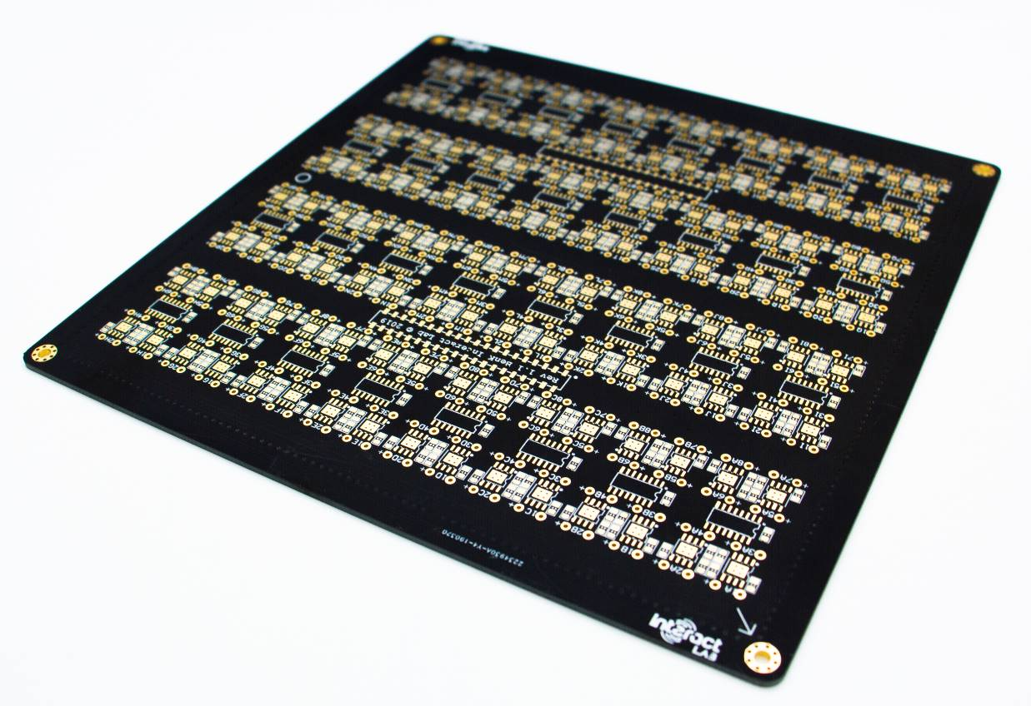

Figure 31 Cleaned bareboard

### Header Orientation

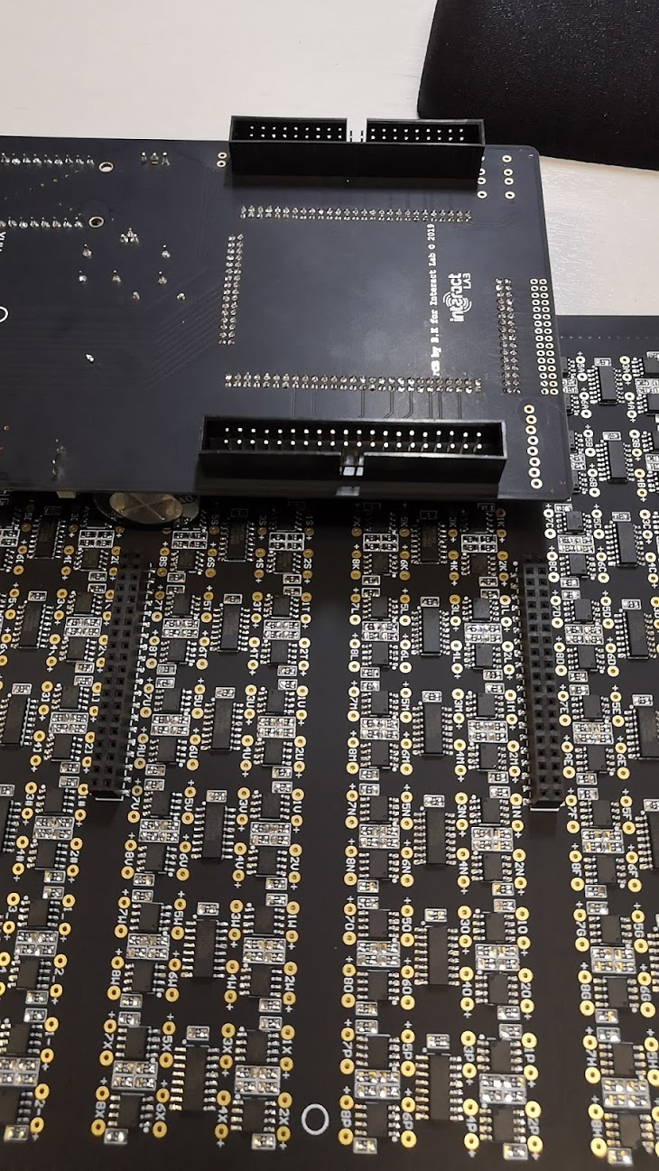

Figure 32 Header and socket orientation

As shown in the image above, we can see that the Controller board’s headers are protruding from the bottom of the board. The Array board’s sockets protrude on top of the board allowing the two boards to mate.

### Soldering the SMT components

As always, we clean the board with IPA. We then carefully place solder paste on the pads using the stencil (stencil Gerbers are in the zip file and can additionally be extracted from Altium).

Use the stencil shown below to apply solder paste to the exposed pads, there are around 2750 of them, so doing this with an iron by hand will take a long time and prone to errors.

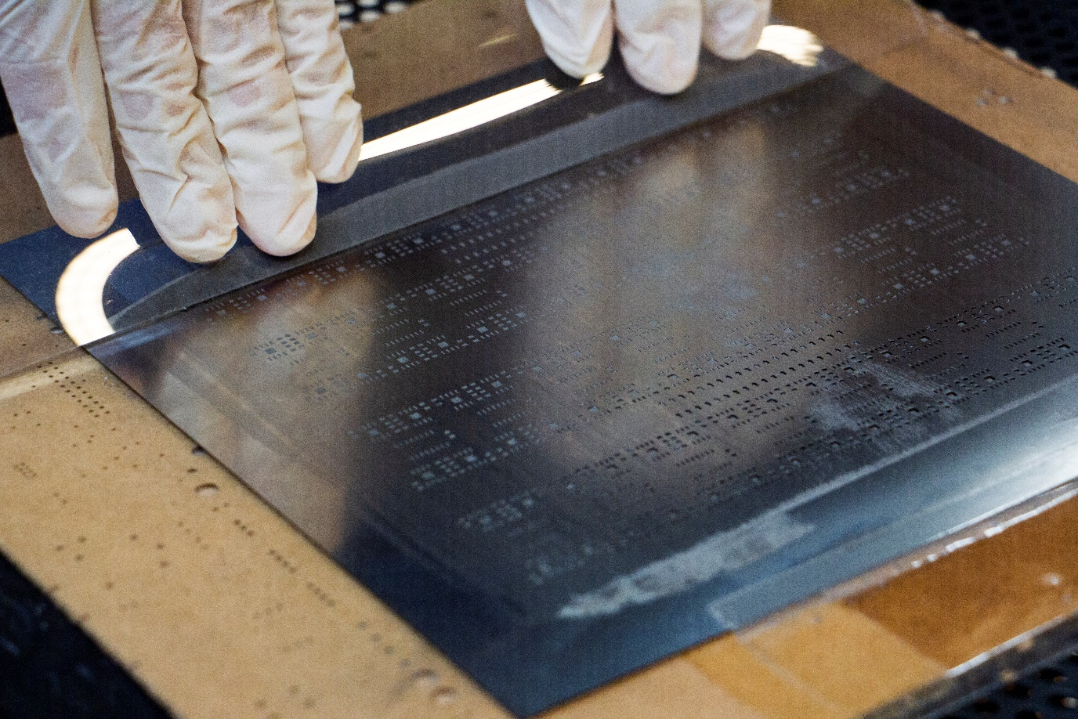

Figure 33 applying the paste

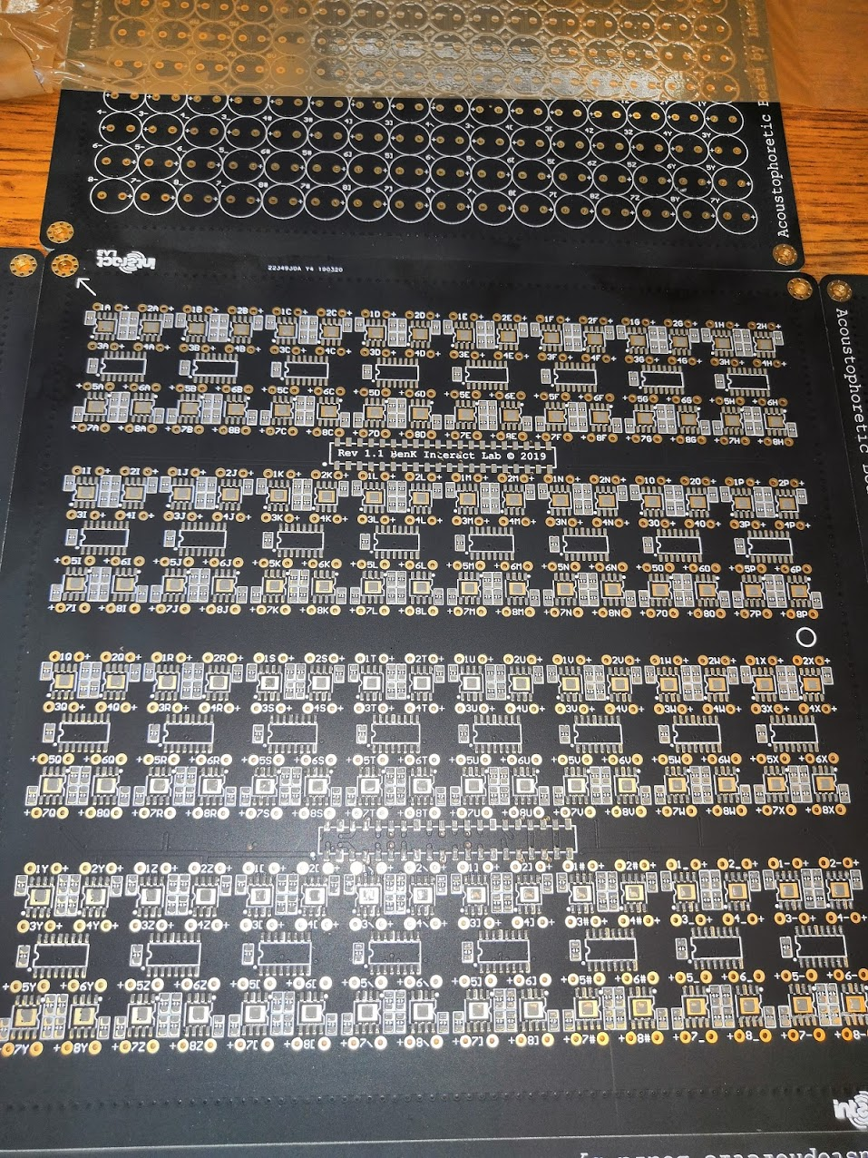

Figure 34 a completely pasted board ready for population

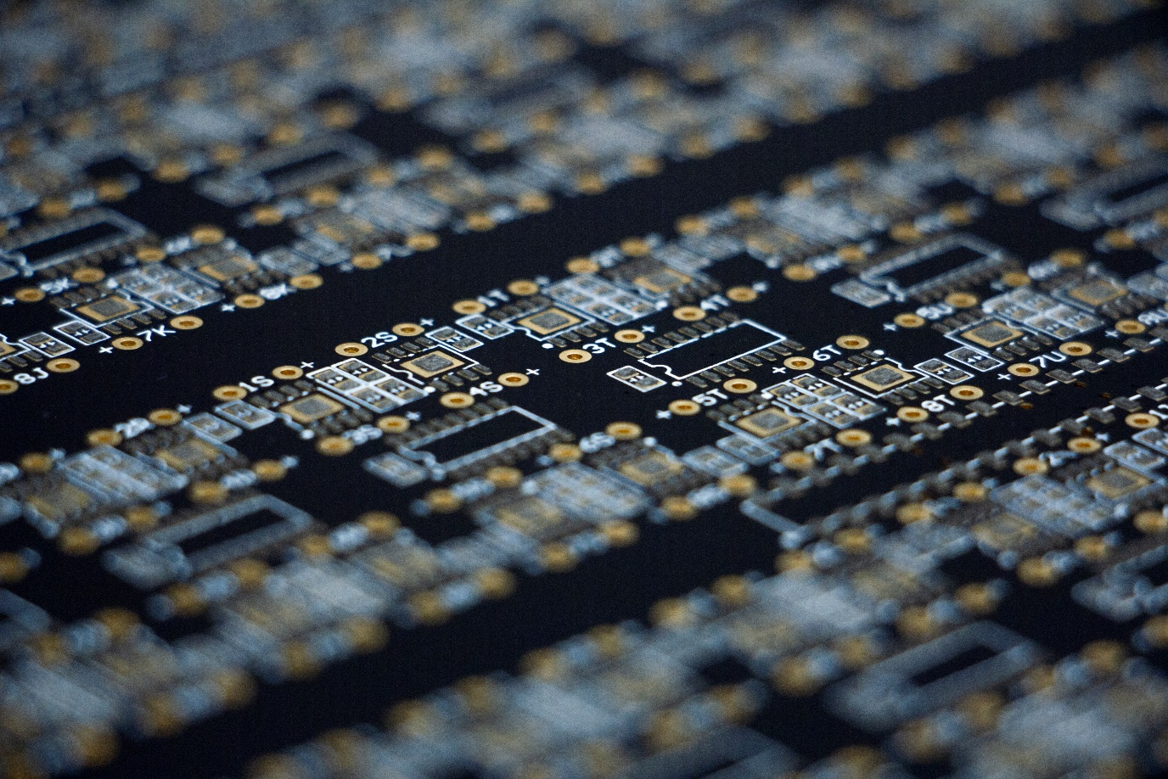

Figure 35 Applied paste

Carefully use fine tweezers to place first the capacitors, then the ICs. Try your best to align the components over the pasted pads.

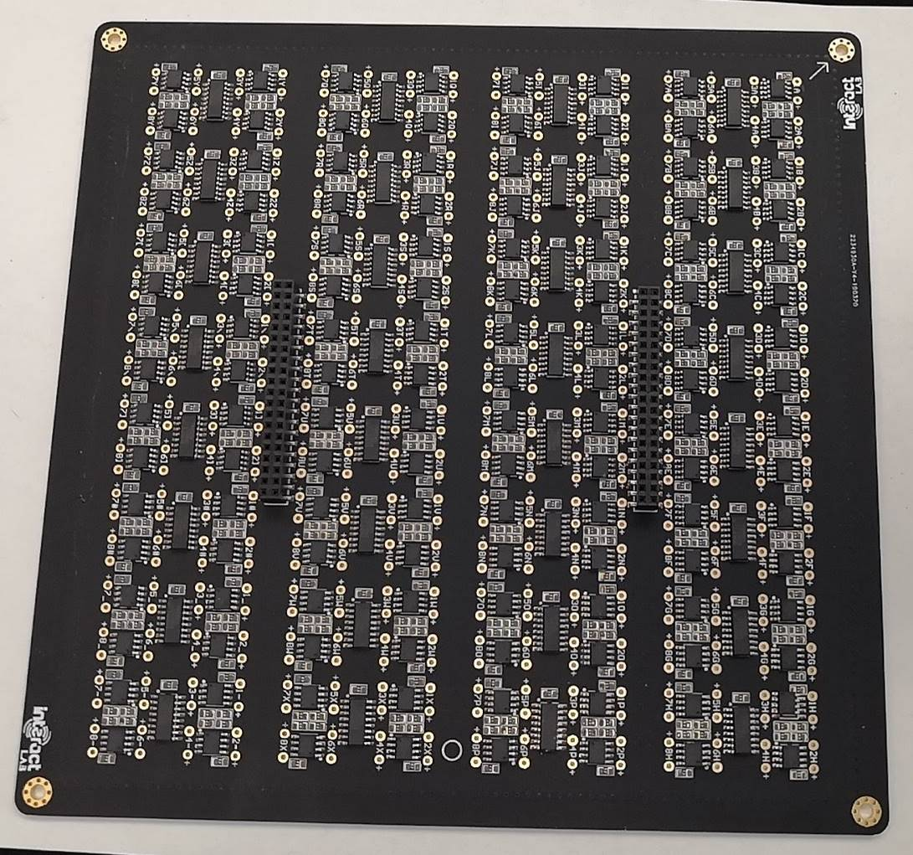

Figure 36 All SMD components placed before baking. Orientation is critical, and alignment will make everything easier in the next steps

Do not use a hot air gun to reflow the components as this will warp the board, or if you must, be very careful and conscious of the consequences of isolated heat spots and the subsequent warping they create. The board has many copper layers and thermal resistance, so one segment of the board can be 350c while the other remains room temperature, causing warping. This usually isn’t such a problem in other projects, but this array board holds the transducers that must remain flat and flush with one another.

Place the current board with the paste and components into a reflow oven and follow a reflow temperature suggested by the solder paste documentation that you’re using.

Once the board has cooled down from the oven, pay close attention to inspecting the board for shorts and deal with that appropriately. Take a little flux over the short, and set a soldering iron to about 390c, and briefly dab the tip to the short and pull away in the direction of the pad to separate the short.

After, clean the board with flux remover and isopropyl alcohol.

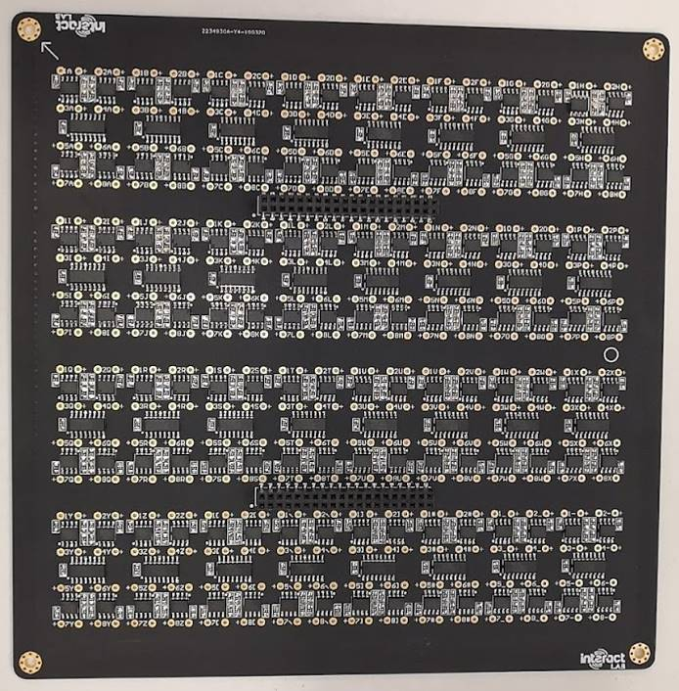

Figure 37 Baked board

### Seating and soldering the transducers

Now we can flip the board over to start placing the transducers. The height of the soldered sockets provide enough clearance for the transducer pins to protrude.

We can now place the 256 transducers by hand, pay close attention to push them all the way through.

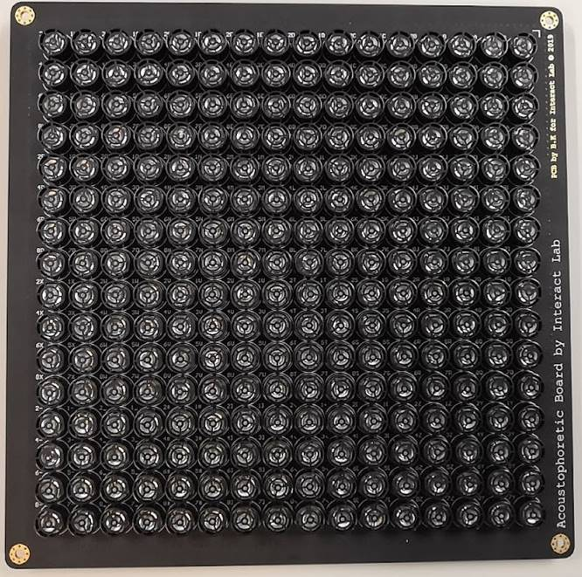

Figure 38 all transducers placed and ready for soldering

Once all of them are seated, one must be very careful not to jog the board as spilling the transducers at this stage will be frustrating.

Laser cut the ‘Motherboard Transducer Jig.cdr’ file on a 10 mm piece of acrylic. Make sure it is 10 mm thick as we need the jig to be rigid.

We want the bottom of the transducers to be touching the PCB. The acrylic will help us hold the transducers in place when we solder them.

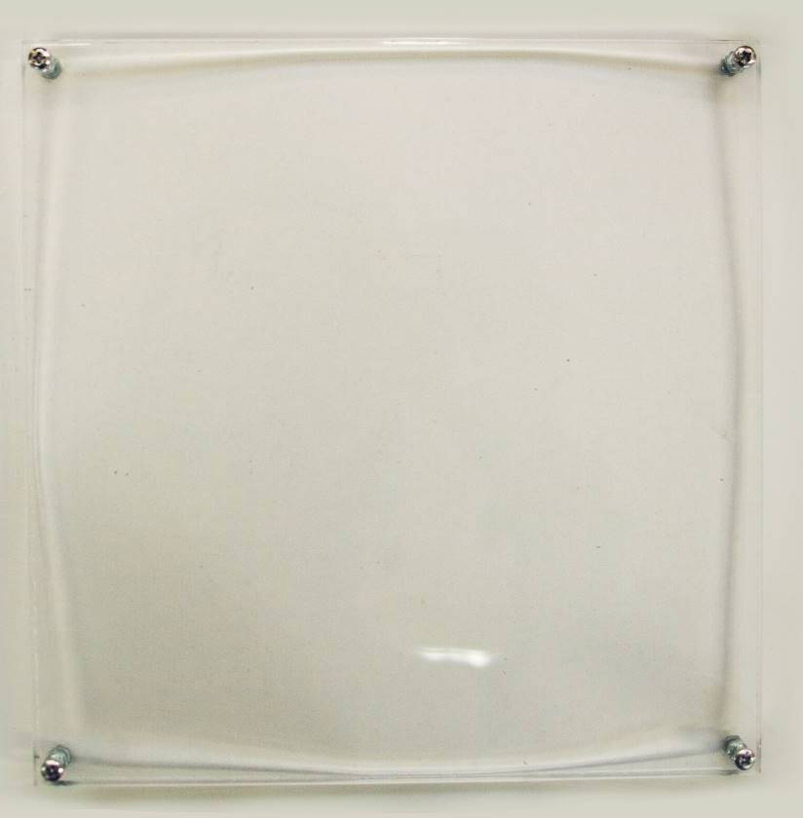

Figure 39 the jig

We want to use the correct nuts and bolts as shown below with the intent to hold and tighten the PCB to the jig.

*You can get away without using a jig like the one shown above, but the author suggest it if you plan on making more than a few boards. You can use a large flat piece instead of the jig but be very careful not to jolt or accidentally move the flat piece as it won’t be connected to the PCB.*

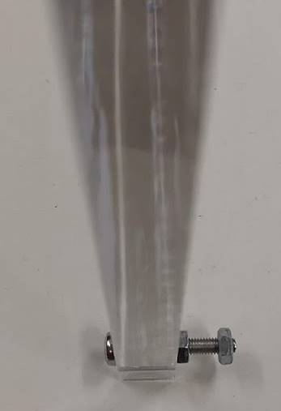

Figure 40 remove the right most nut to place the PCB into the jig

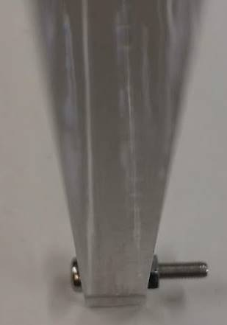

Figure 41 make sure the inner nut is tightened to the jig and gently place the jig over the PCB making sure all screw ends fit through the PCB mounting holes

This design is intended for the acrylic to mate to the PCB, using the appropriate nuts and bolts. Pay close attention to not over tighten the nuts, as doing so will visibly warp the PCB, and create a concave effect post-soldering. We want all of the transducers to be flat and flush, so only tighten the pieces together enough so the transducers don’t move around when we flip the PCB.

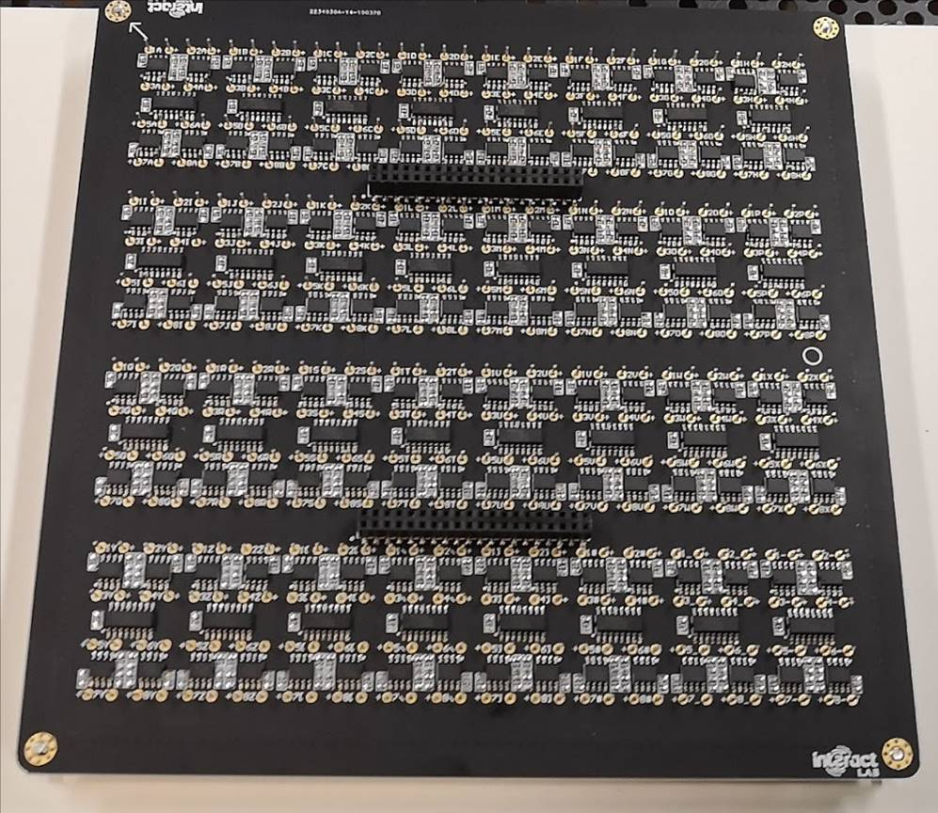

Figure 42 screw the remaining nuts into place. Do not overtighten

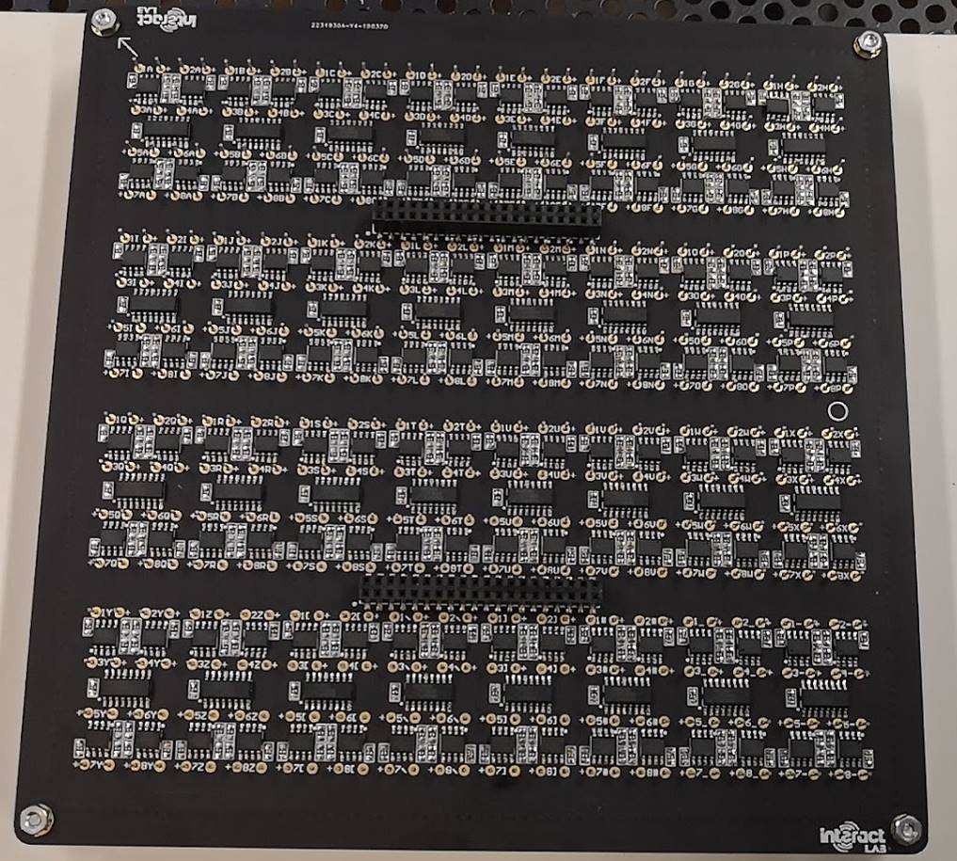

Figure 43 with the nuts in place

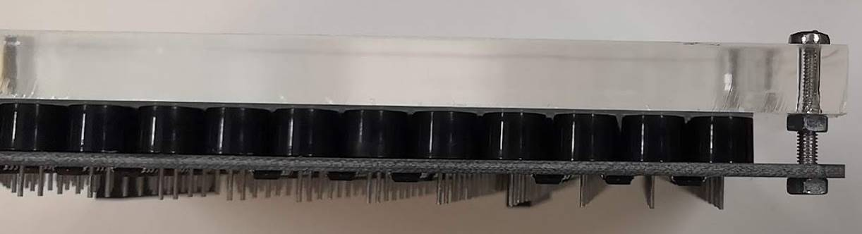

Figure 44 the coupled unit

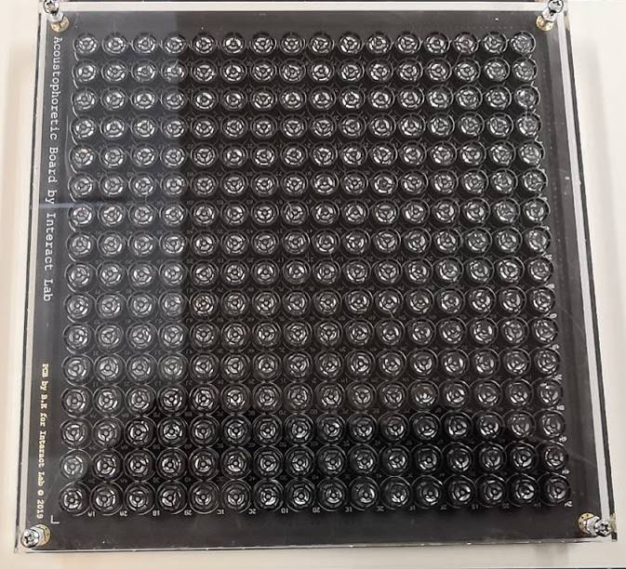

Figure 45 don't forget to add the second nut to lock the PCB into place. Now you can flip the coupled unit around and make a judgement on whether the transducers are flush with one another by seeing through the transparent acrylic

Use a soldering iron and an easy to use solder core to solder the 512 connections. 256 of these connections are to a ground connection, and due to the six layer PCB we find much of the heat from the iron sinking into the board. So set your iron to 450 c.

At this point, if you find you’ve made a mess with the flux, apply tape to the top of the transducers, then use flux remover and isopropyl alcohol to clean the side we just soldered. Then remove the tape. The tape is to stop any liquids from going onto the transducer element.

Now we want to make sure each of the transducers are flush, if not then use a de-soldering tool to take appropriate action.

ID and tag the Array board and congratulate yourself on finishing it.

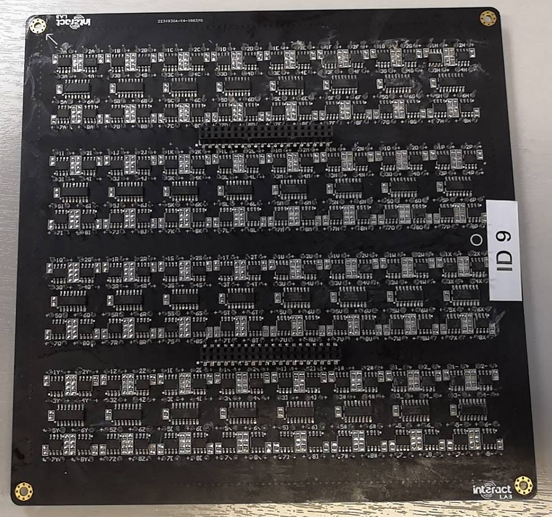

Figure 46 finished Array board

### Testing

Now the two PCBs taking care to align the pins and orientation correctly, doing this bit incorrectly will set you back a long way. Newer builds will have alignment and orientation locks.

Place mounting stands on the array board so the array board emitters are facing upwards. You may need to improvise to get the height of the stand offs great enough to clear the large capacitor on the Controller board.

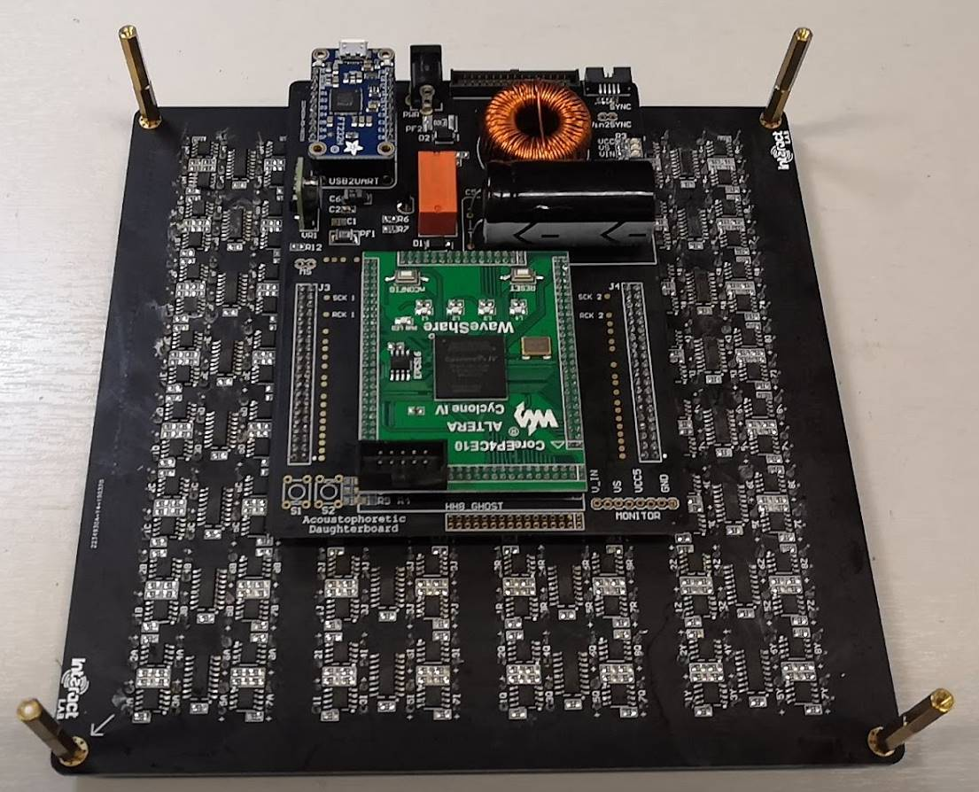

Figure 47 coupled boards with stand offs



Figure 48 coupled board standing on stand offs

Before applying power, take a digital multimeter and set it to continuity, and make sure using the ‘monitor’ header on the controller board that there is no continuity between ground and V_in, ground and VS, or ground and VCC5. If there is, disconnect the two boards and take the measurements again to help you pinpoint the short as there will be one. Find it and take corrective action.

If you have no continuity then you are safe to plug in a centre hot 20 V barrel to the daughter board **after plugging in USB**. Here you should see the VCC and VIN LEDs light up. We can now plug in a JTAG USB Blaster to the FPGA board to program the FPGA. Cold cycling the power to the board will then boot the board into a desired state.

Figure coupled board powered up. See the power LEDs are lit

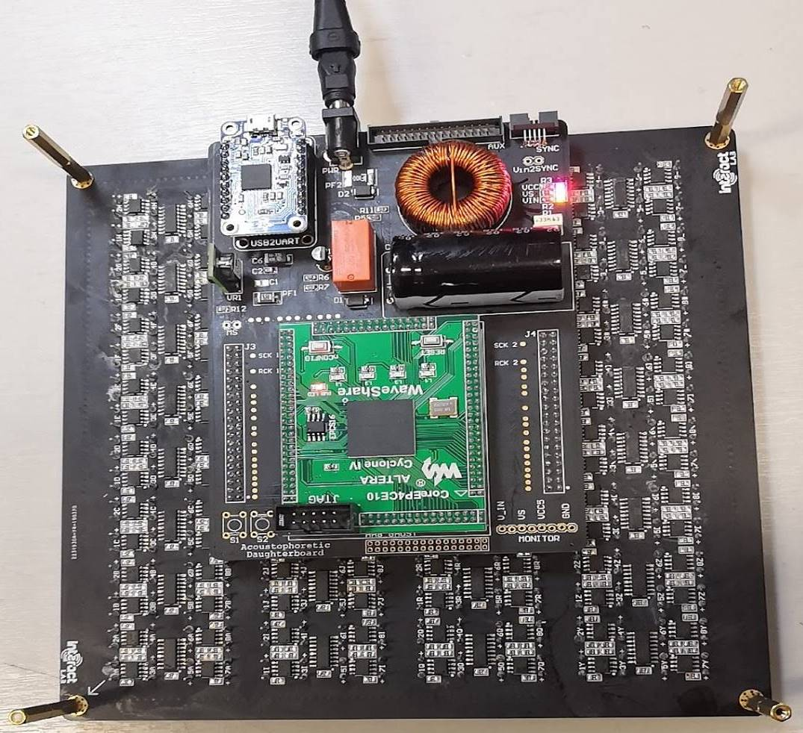

Set all of the data outputs to output 40 kHz.

Set an oscilloscope probe to clasp a single transducer, we will use this to couple with each of the transducers in-turn to make sure they’re emitting a 40 kHz sine wave.

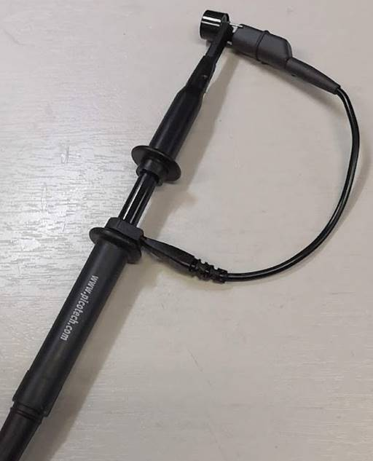

Figure 50 clasped transducer used as a microphone to check emitting transducers

We need to probe each of the 256 emitting transducers once the test firmware has been uploaded.

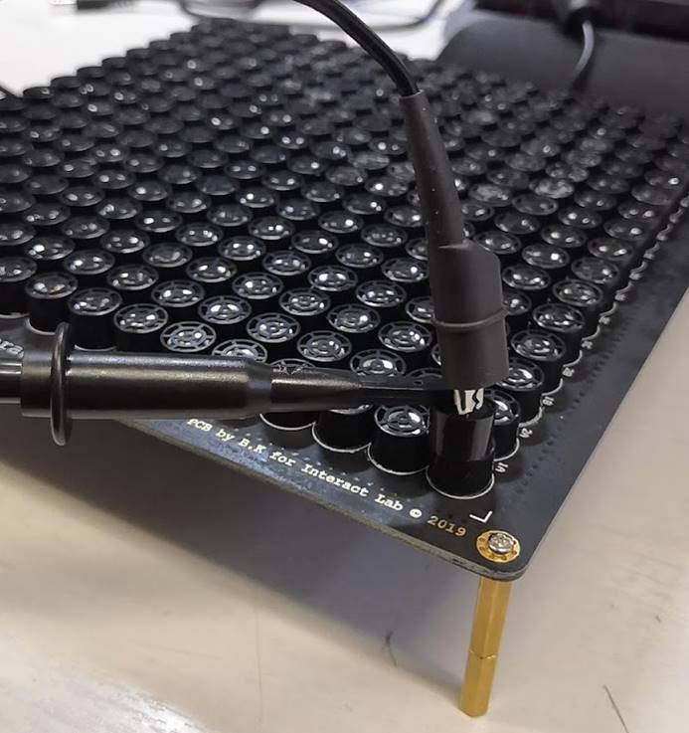

Figure 51 probe transducer used to check each transducers functionality

If they’re not then corrective action should be taken. Sometimes the transducer is at fault, but it is wise to use an oscilloscope probe to carefully check various stages and pads for the connection from the FPGA (each data line has an associated test point on the controller board), through to the pre and post amplification stages. If the positive leg of the silent transducer is receiving a 20 V 40 kHz square wave signal then we know the transducer needs to be replaced.

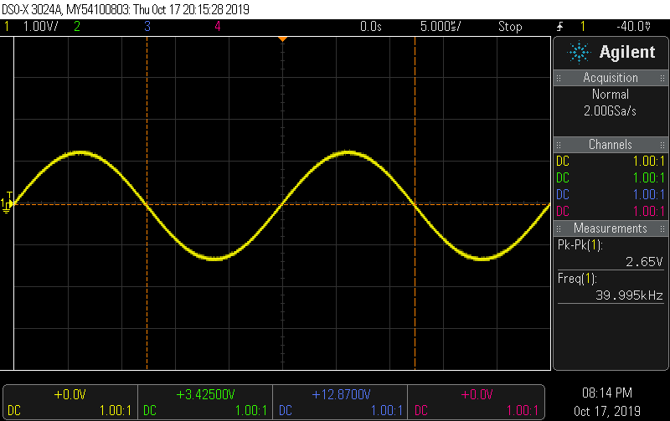

Figure 52 using a probe attached to a transducer to test each emitter. The scope will show a 40 kHz sine wave

### Using a thermal camera to test the board

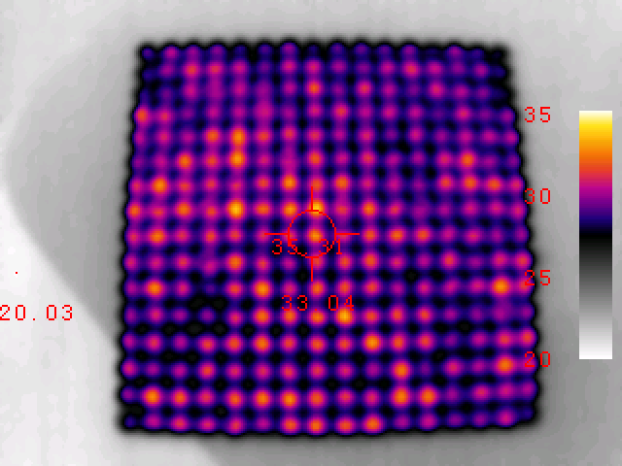A thermal camera can alternatively be used at this stage to verify the board since each transducer creates heat, so there should clearly be 256 distinct heat sources. Note, it is much easier to see a differential in heat if the board is cold, I.e. a board that has been on for ten minutes will not sure a big temperature differential so it won’t be very useful to use a thermal camera at this stage – let the board cool down then analyse the temperature.

Figure using a thermal camera to view the board, we can see here each transducers heat source.

# Calibration

The calibration process only applies to the Array board.

## Identifications

It’s important at this stage to add a label to ID each array board, since each one has a different calibration. Furthermore, it’ll be possible to keep track of complete builds that have an ID number.

## How to calibrate the Array board

**Many quality transducers including the transducers we use from ID 48 do not need to be calibrated. If you find yourself with transducers that output at slightly different phases, or that you unknowingly soldered the transducers with differing polarities, then this section will be important to follow.**

From the factory for boards before ID 48, each transducer has a slightly different phase, so corrective action is taken by measuring a square wave generated from the FPGA on one channel of an oscilloscope and referencing this to each of the 256 transducers using another probe with the single transducer. We can use the oscilloscope to measure the phase difference using a built in ‘measure’ mode.

Take note of each difference and use this array in your C# program.

We do this by using two probes on an oscilloscope, one connected to a 40 kHz square wave driven by the FPGA as our reference signal, and the other from each emitter’s output sine wave. We can make things easier by using the ‘phase’ measure tool in the scope, noting each emitters phase difference from the reference signal into an excel sheet. Take care to match the transducer ID’s to that in the C# code.

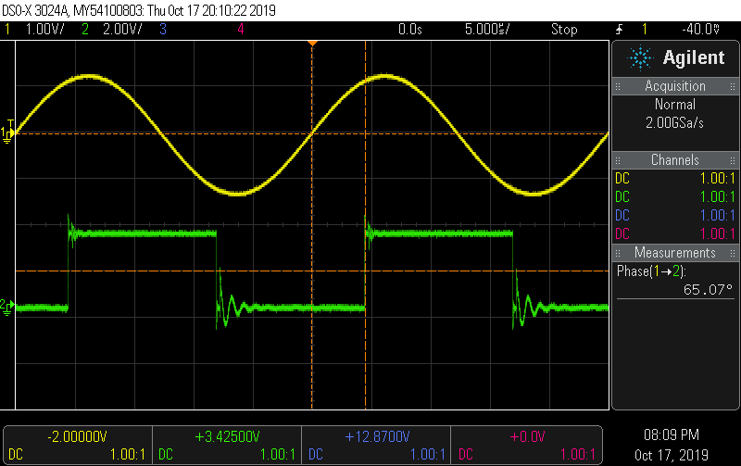

Figure 54 take note of the phase difference for each emitter. In this case, the phase difference is 65 degrees

# Interfacing the Dual Setup

You may want to interface two boards in a dual setup allowing both arrays of transducers to face each other, allowing a more stable levitation. To achieve this, it’s important to first know which IO ports we will be using. In section 1.1.1 we describe each IO, those necessary highlighted below are: Sync, Power, and USB.

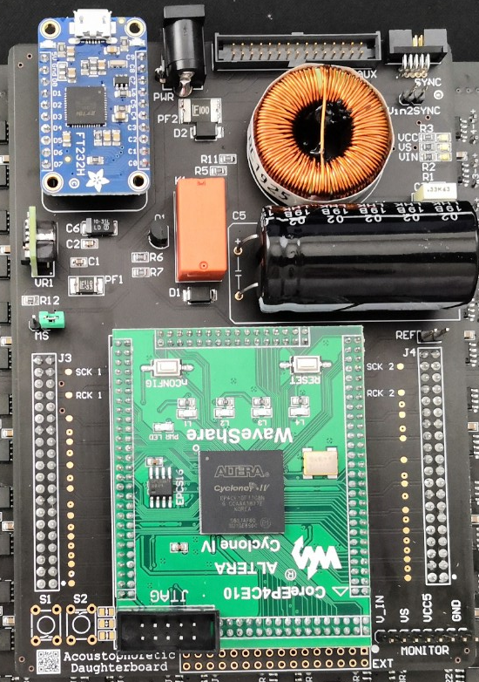

Figure 55 Shows the necessary IO for dual board interfacing

## Dual Setup Block Diagram

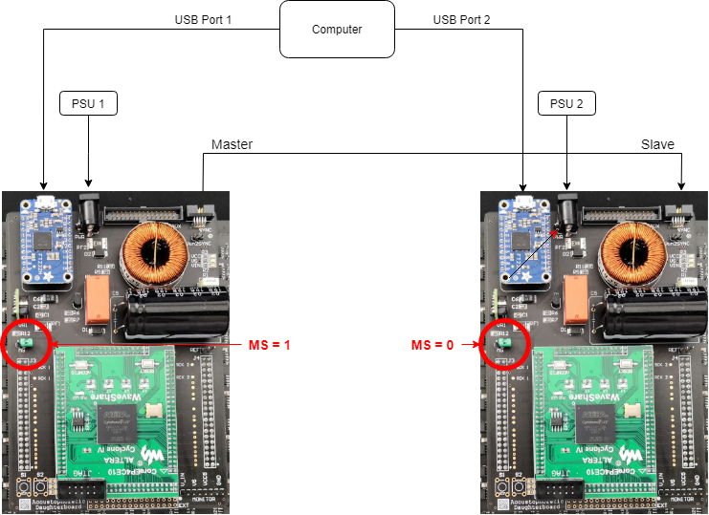

Figure 56 shows a dual board setup interface

It’s paramount that you use a jumper to short the MS on **one** board, this will let the firmware know whether to sink or source the synchronisation signal.

You must plug the sync cable in first, then the USB ports into the boards, followed by the power jacks, this will get the board into a defined default state where all the transducers output a uniform 40khz sine wave.

Note, this setup currently requires two power supplies, and two USB ports from the same computer.

# Building a dual board case: Overview

The PBD (Particle Based Display) case is a comprehensive design for holding the electronics necessary for the MSD lab’s PBD and levitator technology.

This version of the case simplifies previous revisions by using the side braces as pillar supports with engraved rulers and centre holes to easily measure and centre beads. This allows for an almost 360 degree viewing angle for your exhibition.

This guide contains instructions and tips on how to construct and assemble the PBD case. All parts are referred to as per their respective file name.

# Case: Bill of Materials

This version is constructed from 5mm acrylic, several nuts and bolts, and some acrylic glue, we like to use ‘Tensol 12’.

We expect different readers to use different sized panels of acrylic, therefore each part to print has been saved as an individual file giving the builder freedom to place each design on panels of various sizes. Because of this, we will not specify a quantity of acrylic below.

All acrylic is to be cut 5mm thick. You may choose the colour of the acrylic, although we recommend darker colours to allow the beads to be easily visible.

*As a guide, we have used around four to five 600x300mm 5mm acrylic in the past for similar designs.*

The full list is below:

|  |  |  |  |
| --- | --- | --- | --- |
| **Part** | **Size** | **Quantity** | **Notes** |
| Acrylic | 5mm | NA | Black |
| Bolt | M4x20 | 7 | Dome cross or socket head |
| Bolt | M2x15 | 8 | Dome cross or socket head |
| Nut | M4 | 7 |  |
| Nut | M2 | 8 |  |
| Tensol 12 | 250ml | NA | Glue for Acrylic |
| Gloves | N/A | N/A | Safety gloves when gluing |
| Clamps | 250mm | 4 | Highly recommended |

# Laser cutter files

All files included should be laser cut in Acrylic.

Each unique part to be cut has its own associated dxf file in the format:

“thickness” + “quantity” + “name”. dxf

Each piece in this design is to be printed on 5mm acrylic panels, but some pieces need to be cut more than once. The quantity is specified in the filename.

For example, we want to cut the following piece eight times: “5mm_8x_HexLock.dxf”.

We advise laying out these pieces on any panel size you may have, then laser cutting that panel rather than printing many parts.

## DXF format

The DXFs use the following format:

RGB Red line = vector cut

RGB Black line = raster engrave

You may find that you need to re-colour the lines as per your needs.

# Abstract Build

## Top Hierarchy Assembly

There are images throughout this document that reference Autodesk Inventor CAD files. These images show different multi-colour acrylic pieces. It is important to note that the colours chosen for each acrylic piece are purely to aid the reader in differentiating the different parts and bear no resemblance to what your final case should look like – however you are free to build and modify the case however you please.

The build is primarily two assemblies attached by two side braces as shown below.

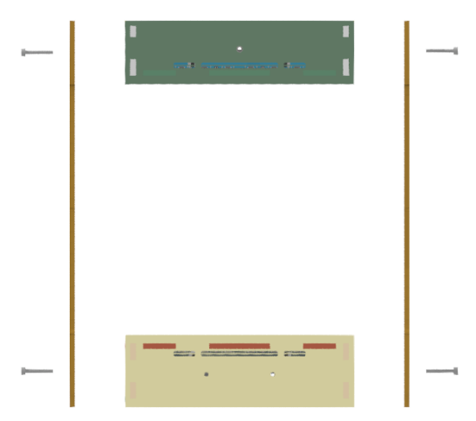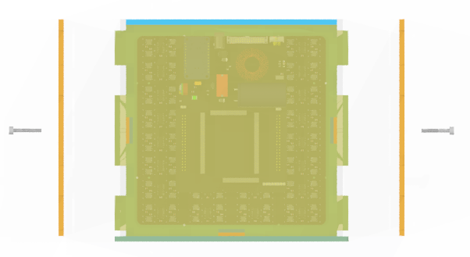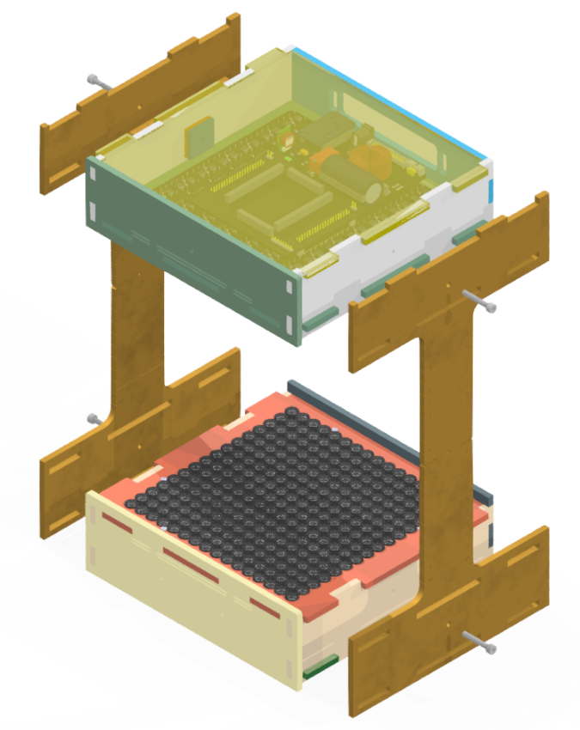

Figure 57 Exploded Assemblies

We like to refer to the top assembly and bottom assemblies that hold each of the acoustophoretic boards as boxes. Each box acts as a mount for the electronics and gives easy access to the IO on the rear, then provide slots for the side brace which couples both so to hold each array 24cm apart. *This measurement is taken from the top of the transducer casing.*

You can see the four M4 screws above, these couple the side braces to the top and bottom box, the screws are not included in the top and box assemblies themselves.

## Top Box Assembly

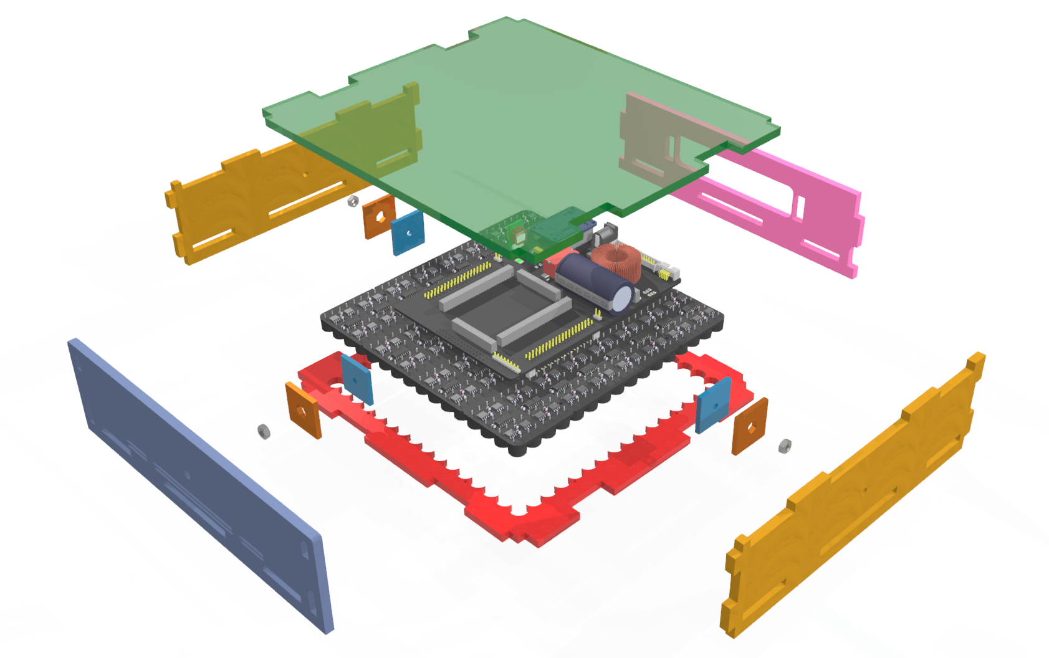We will look at each of the boxes in an exploded view to better understand how the pieces go together.

Figure Top Box Assembly

Above is the top box assembly, we can see each of the boxes has two side walls, a front wall, and a rear wall. The electronics mount to the jig (red) that holds the board in place, it also slots in to the two side pieces, the front piece, and the rear piece.

You may also notice the M4 nuts, these go inside the box and allow the M4 bolts from the outside of the side braces a thread to lock into. We use two small acrylic pieces to hold the nuts in place; one piece is in the shape of the hex nut; the other is a hole for the excess bolt to extrude from.

Additionally, we have a modular top flap which we call a cover. On the top side, it is optional and easily removable just by lifting.

As the render suggests, we slot the electronics into the red jig from above.

You may have noticed that we don’t have screws holding the top electronics to the top box, that’s because the screws in the top box are optional, we let gravity do most of the work there. We do recommend using screws if you expect to move the box, and they are required on the bottom box.

The front wall (left) has a single screw hole, this is for an optional camera mount.

## Bottom Box Assembly

Figure Bottom Assembly

Unsurprisingly like the top box, the only difference are the optional screw holes on the front wall and the required M2 nuts and bolts between the board holding jig and electronics board.

Note, we always place the M2 screws, so the head is on the side of the working area, in this case on the top as shown above. We don’t want long screws to extrude into our levitation working area.

The front wall has two screw holes for optional hand tracking hardware, in our case, leap motion.

You may have also noticed until the top box; the bottom box cover (the bottom piece) is not modularly designed. If you want to remove it, you need to loosen the side bracers. We advise adding both box covers as you don’t want foreign objects touching the sensitive electronics.

## Side Brace Assembly

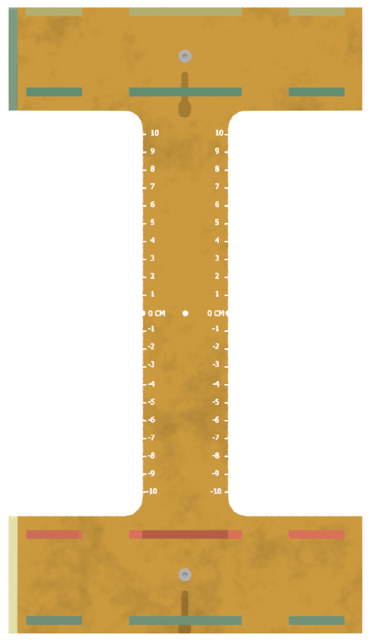

Figure 60 Side Brace Part

The side brace is designed to give a maximum viewing angle, there is a centre hole to allow the user to centre the levitated bead quickly and easily to the correct trap height. Alongside this, there are engraves on each side showing the distance from the centre point which may become useful.

## Complete View

Below is a complete exploded view of the entire case including the electronics (without the wires).

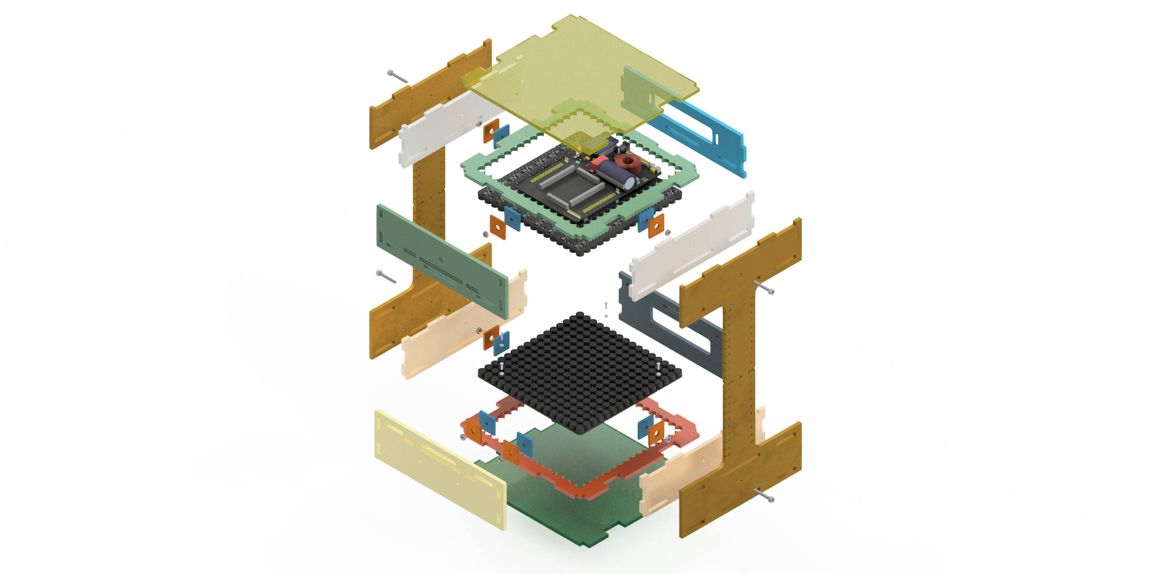

Figure 61 Complete Exploded View

# Cutting the top and bottom boxes

Our Rev 3 Array PCBs have trimmed edges so as to be flush with the edges of the outer transducers. Each edge has two m2 semi circle slots per edge.

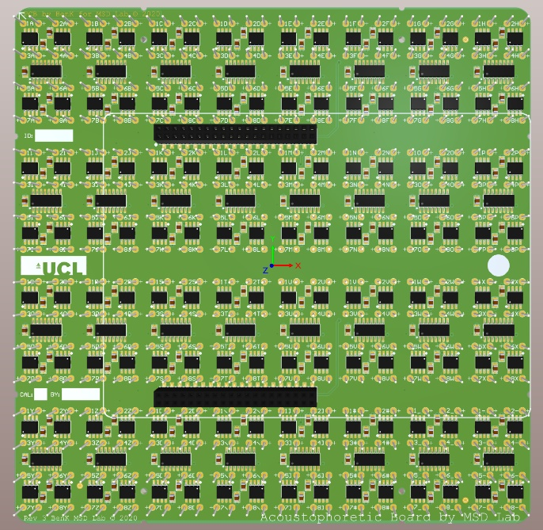

Figure 62 Rev 3 Array

## Step 1: Cutting

First you must cut all the dxf files as per the quantity stated on 5mm acrylic. It’ll help to annotate each piece as you go so you remember where each piece goes. The filename should help you know what to write on each piece you cut. Try to keep all the ‘top’ pieces together and separate from the ‘bottom’ pieces, this will make things easier when you start gluing the pieces together.

## Step 2: Top Box

Take two *top case sides*, one *top case back*, one *top case front*, and one *top case board holder*, and assemble as illustrated below. Glue along all touching edges. Once you’ve done this, it may help to glue each adjacent corner that you’ve just glued to form a good joint, this is a good practice for all glued pieces going forwards.

Note, the glue type specified uses capiliary action and will only work if the pieces are tightly held together while the glue sets.

We recommend using clamps to tightly hold the two side pieces together simultanously as you hold the rear and front together, you want each piece to be slotted fully and straight with respect to its adjacent piece.

The drawing below should aid you with this.

Start by first attaching the sides to the top board holder then attach the front and rear (back) side.

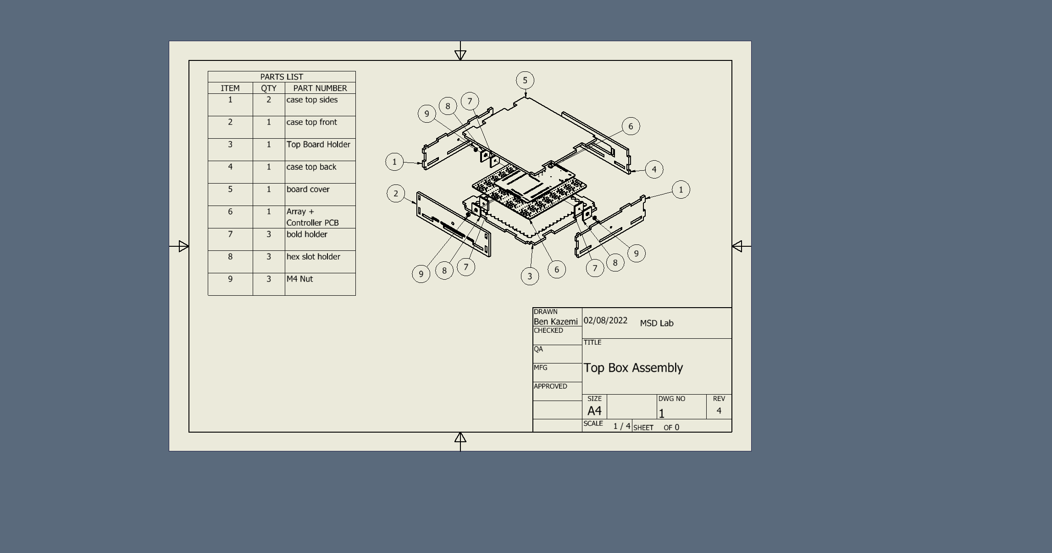

Consult the glue datasheet to know how long you should leave each piece to set.

You should have something that looks like this after the glue has set and the clamps have been removed.

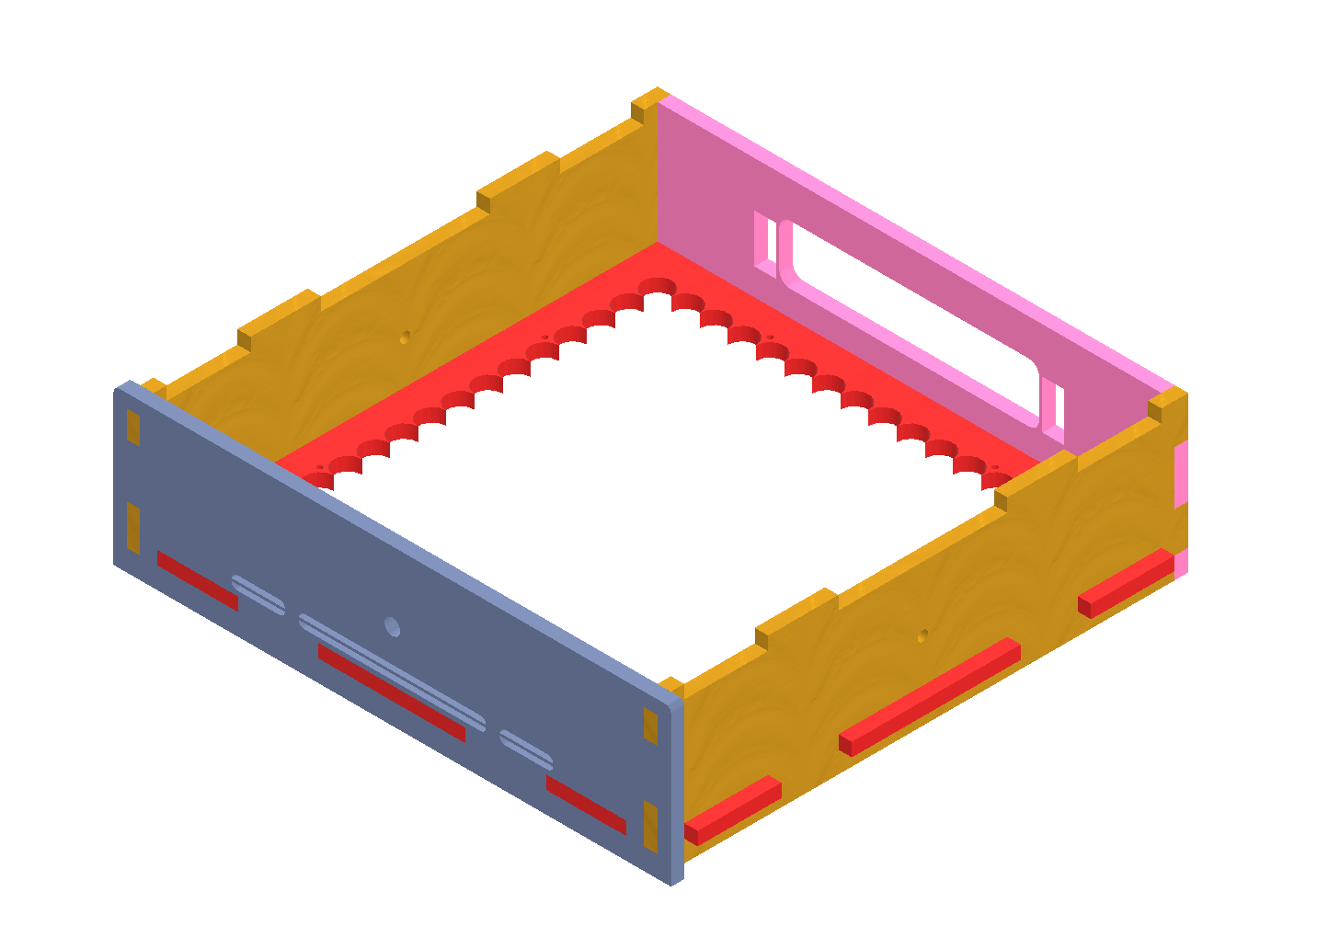

Figure 63 Top Box after the first glue process

## Step 3: Bottom Box

Take two *bottom case sides*, one *bottom case back*, one *bottom case front*, and one *bottom case board holder*, and assemble as illustrated below starting first by attaching the sides to the bottom board holder. Go about this the same way as you did with the top box.

The drawing below should help you identify which parts you need to get started

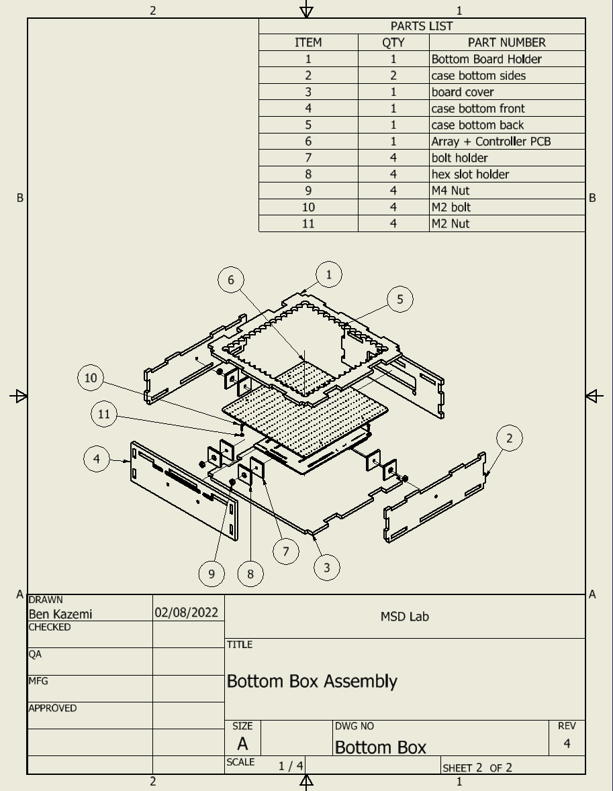

Similarly, at this point once the glue has set, you should have something like this.

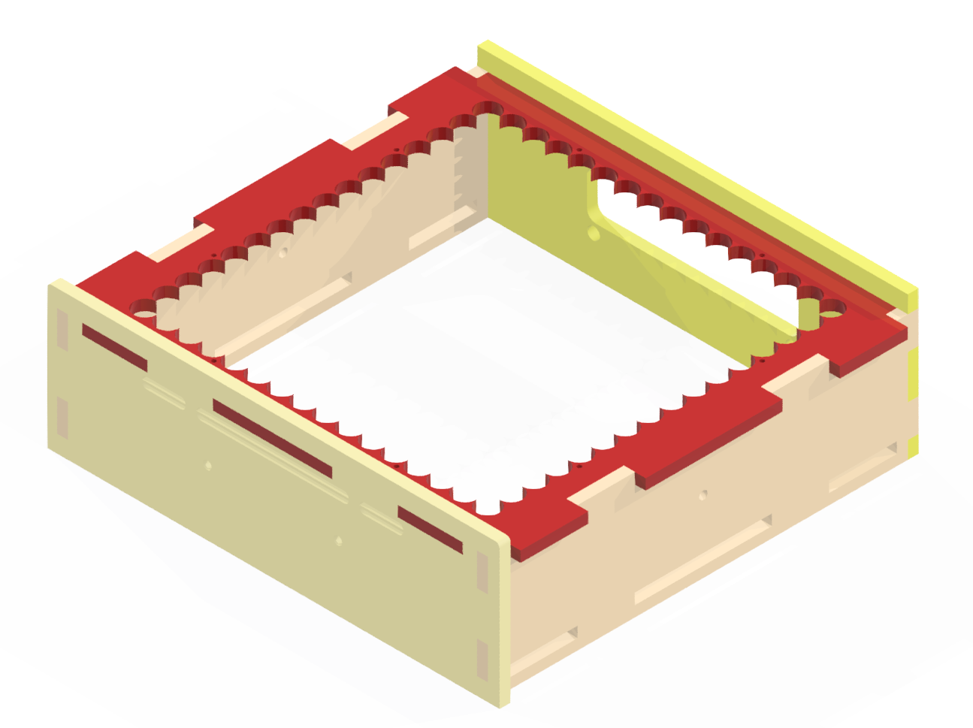

Figure 64 Bottom Box after first glue process

Now you should have both boxes in rudimentary form. We can move forward and make the captive nuts.

## Captive Nuts

Get your seven M4 nuts, seven bolt holder acrylic pieces, and seven Hex Lock acrylic pieces.

The captive nuts give the cases the ability to couple tightly to the side bracers.

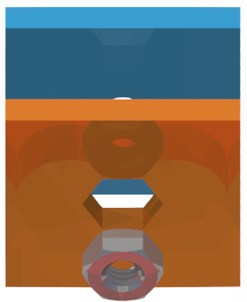

Figure Captive Nut pieces when separated

The idea is to have each of these pieces glued together with and adhered to the sides of the wall as shown in the previous figures to allow a bolt from the side brace to catch and screw to. There are multiple ways to do this, but I find the following the easiest.

We want the pieces above to look like this.

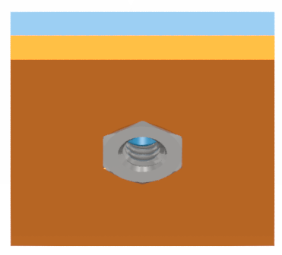

Figure 66 Captive Nut final form

First take each of the seven acrylic pieces and glue them together so the edges are aligned, make sure to follow the application notes of your glue properly, if you’re using tensol12 then you should apply a few drops then make sure each piece is tightly coupled as the glue sets.

You should now have something like the above figure but without the nut. The nut should easily fit, a little play with the nut inside the slot is ok, it’ll function as intended as long as it can’t twist freely when inside.

We now want to glue each side of the hex face to the inside of the top and bottom box sides not forgetting to first insert the nuts.

Let’s take the top box first.

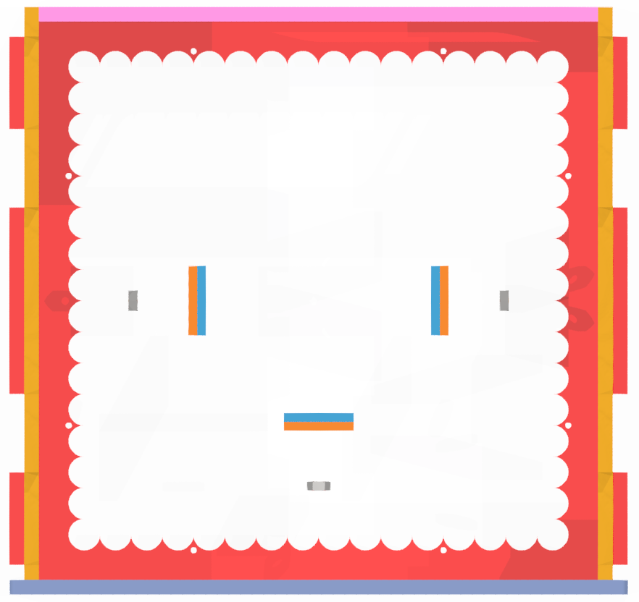

Figure 67 Top box with captive nut

Your pieces should look like the figure above.

The following trick will make things much easier: take an M4 bolt, place it from the outside through the three holes on the two sides and front side, then screw the three nuts by hand until they’re reasonably tight, then make sure the three captive nut acrylic assemblies fit. If everything fits, then go ahead and again place a little glue between the captive nut assemblies and make sure they’re glued correctly with the nut firmly placed inside the captive nut assembly. Once cured, you want captive nut assembly to hold the nut secure as you unscrew the M4 bolts.

Be careful not to glue the bolt in.

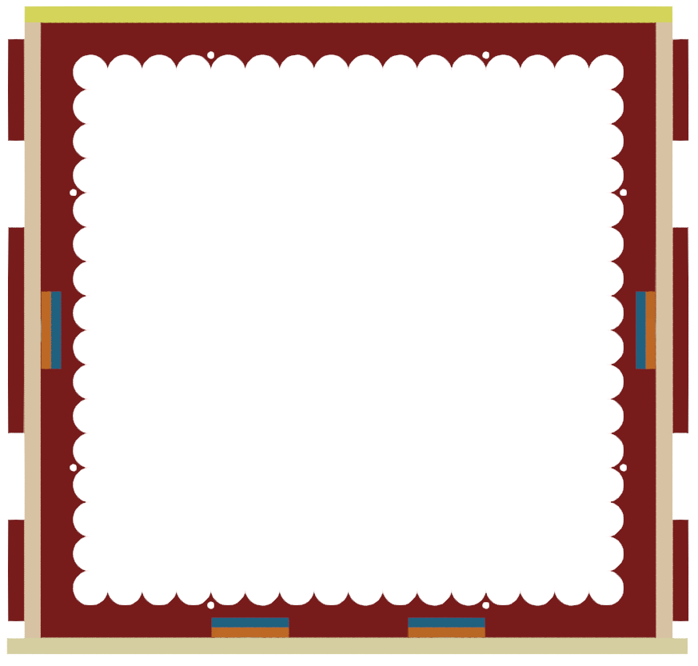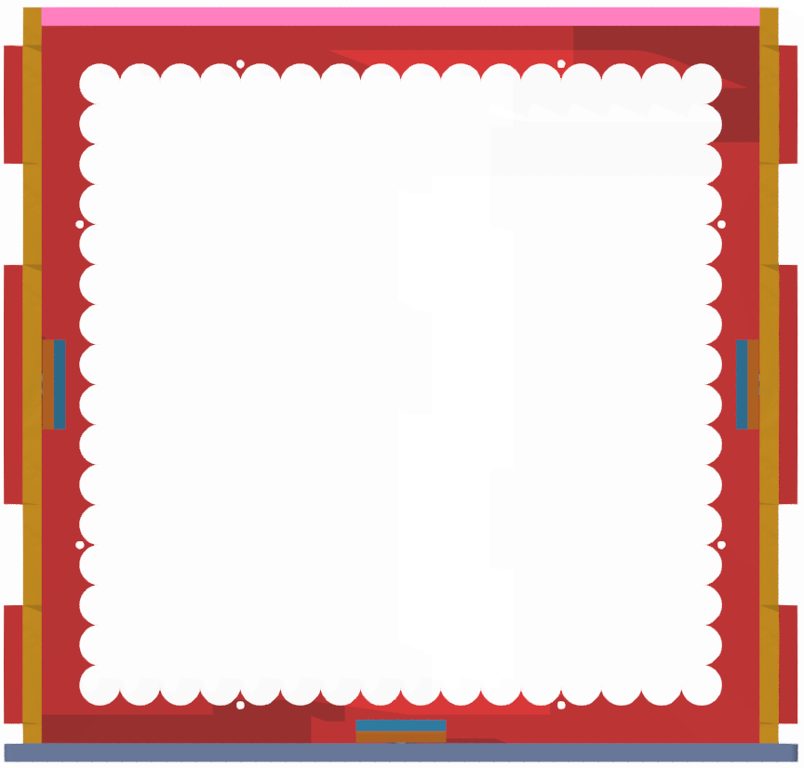Go ahead and follow the same procedure for the bottom box. Once dry, you should be left with the following boxes:

Figure Captive nuts set inside each box

Make sure to remove the guide M4 bolts at this point but only after the glue has dried.

## Bottom Cover

This step is optional but highly recommended. **Keep the bottom cover off for now but remember this step for when you need it later.** Take the bottom cover and place it but do not glue it in place.

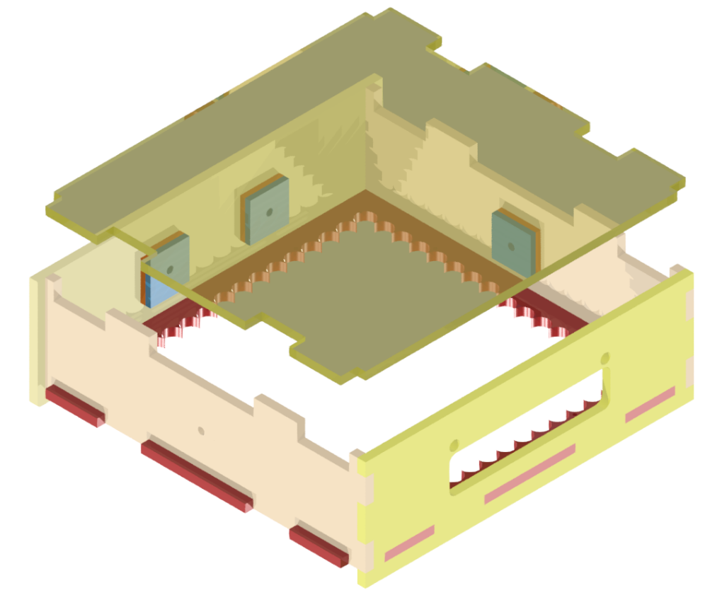

Figure 69 bottom board cover and current bottom box

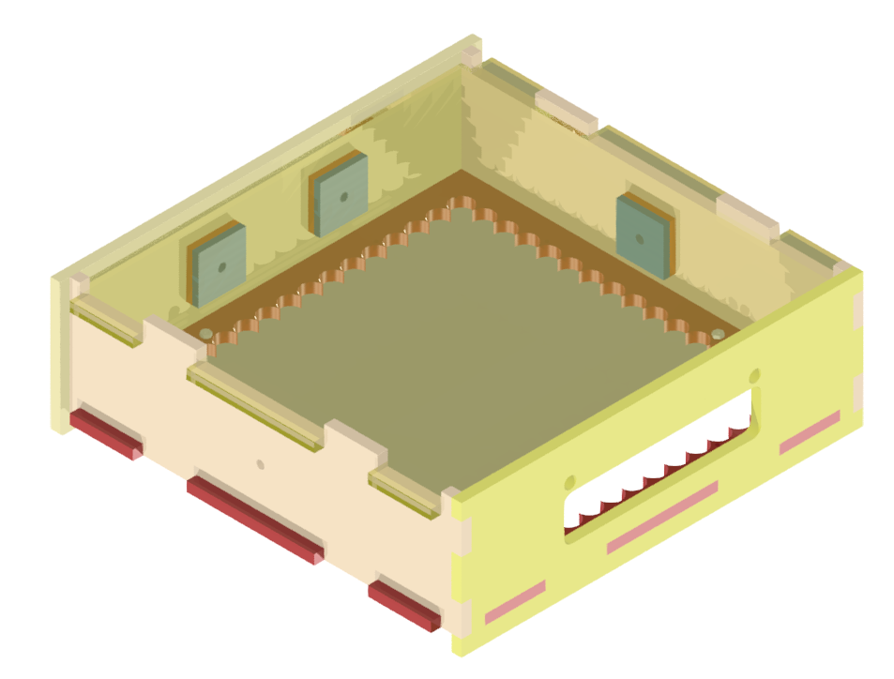

Figure 70 bottom cover in place

You will need to remove the bottom case every time you want to access the electronics.

## Left Side Bracer

We will now attach one of the side bracers. This step may be easier to place the two side boxes on their sides.

You will want to separate the boxes so the side brace can correctly slot into all the extruded pieces as indicated below.

Once everything is tightly slotted in, you will then want to screw in the M4x20 bolts. You will never want to glue in the side bracers.

Be careful when manoeuvring the two boxes with only one side brace attached.

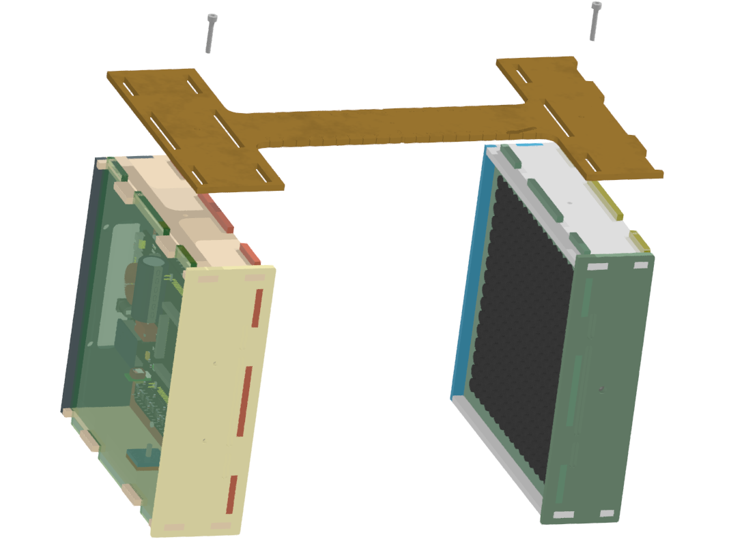

Figure 71 Attaching the left side brace and bolts

## Right Side Bracer

Now carefully and gently flip the assembly over so the left brace is flat and follow the same procedure for the right bracer.

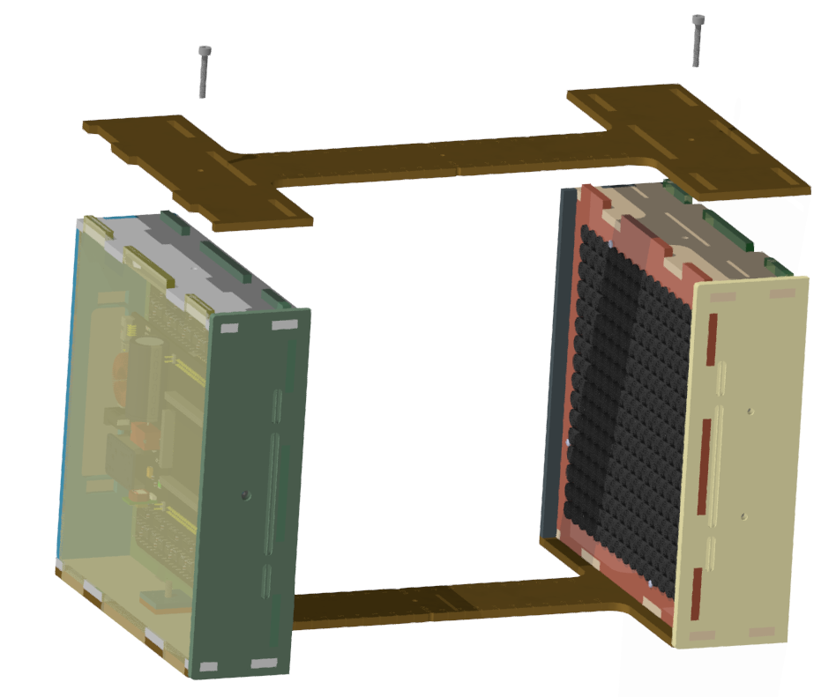

Figure 72 Attaching the right bracer

# Adding the Electronics

### Coupling the Electronics

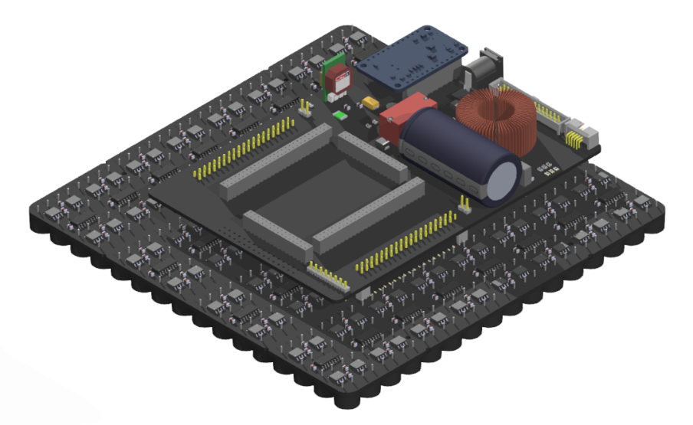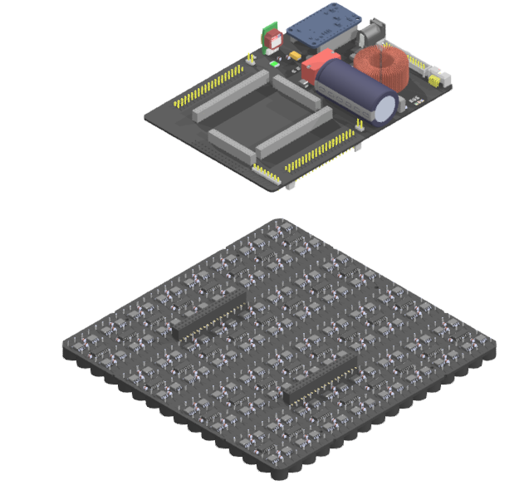The electrical parts of the assembly are covered in other documents, but as a reminded, you will want to couple the Controller and Array boards making sure the orientation is correct and following the silkscreen.

Figure Left: The two electronic boards; Right: the boards coupled

### Bottom Box

Complete this step before working on the top box.

If the bottom box cover is in place, then loosen but do not remove the two bottom M4 Screws. Flip the total assembly then remove the bottom box cover by pushing the side braces aside but not off.

Flip the total assembly if you haven’t already.

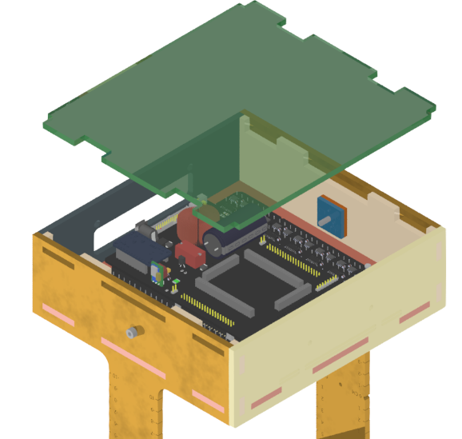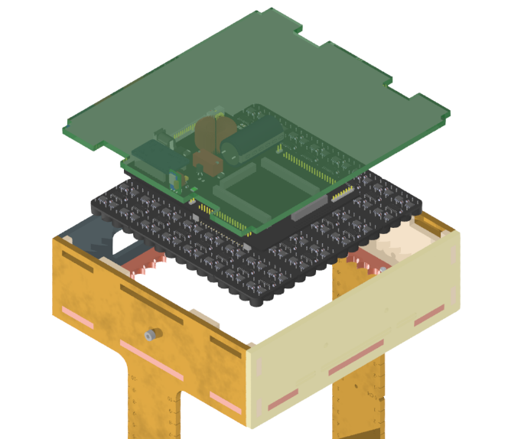With the two box covers off and the total assembly upside down, gently place the electronics again like before.

Figure bottom box cover and electronics placement

Keeping this orientation, push in the four M2 screws one by one from the bottom levitation side and carefully tighten the nuts from the inside of the box. Don’t use a drill. This step is fiddly and using the correct tools will help tremendously. You may even benefit from another pair of hands.

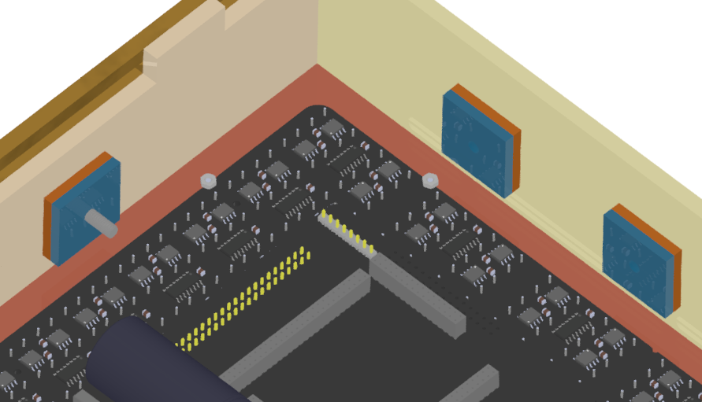

Figure 75 after applying the nuts to the four M2 bolts

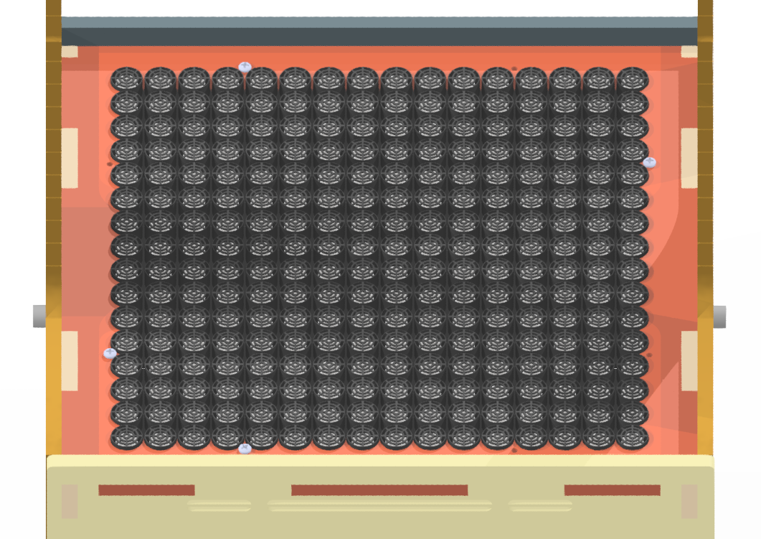

Figure 76 the applied bolts

If you haven’t already, insert the bottom box cover. Do this by loosening but not removing the two side M4 screws that couple the box you’re working on keeping the other two M4 screws tight. Gently push the two side braces outwards so slot in the cover. Re-tighten the screws.

The bottom box should now look like this, flip it over if so – the electronics won’t move.

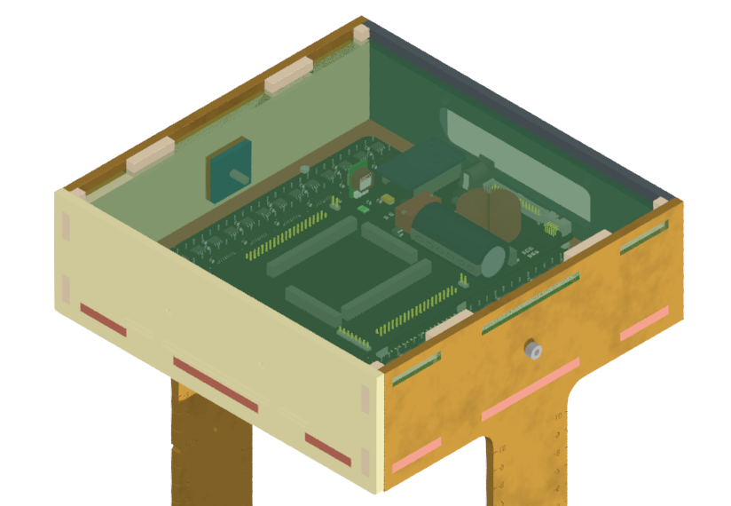

Figure 77 the completed bottom box

### Top Box

Make sure you do this step after placing the bottom electronics otherwise the top electronics will fall out if you haven’t screwed it in.

You will want to remove the top box cover and gently lower the unplugged electronics into the top box.

Make sure to orient the electronics so the IO is facing the rear.

You want the transducers to extrude through the boxes board holder jig with the weight of the electronics held by the PCB. If this isn’t the case, then you haven’t seated it properly.

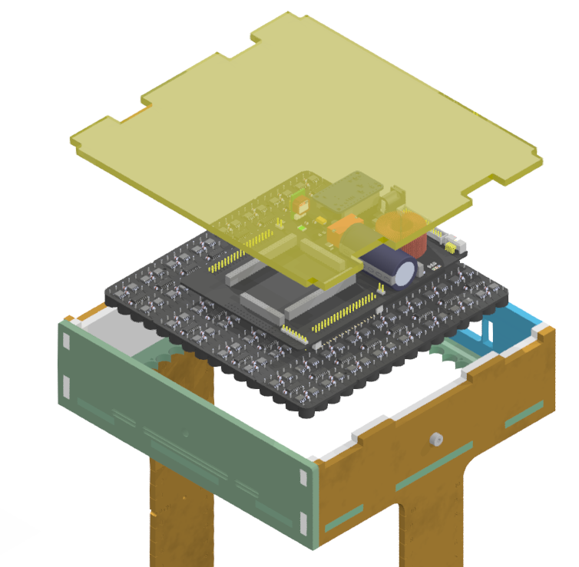

Figure 78 Placing the electronics with the top cover removed

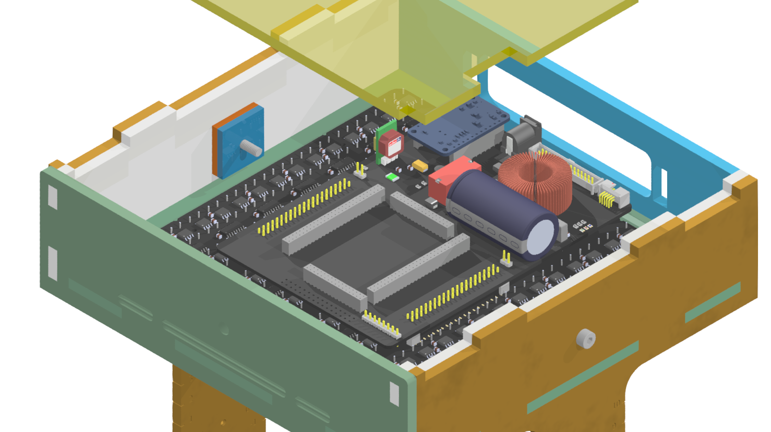

Figure 79 Electronics properly seated

Please the top cover in, it should slot in easily from above.

# Completed Assembly

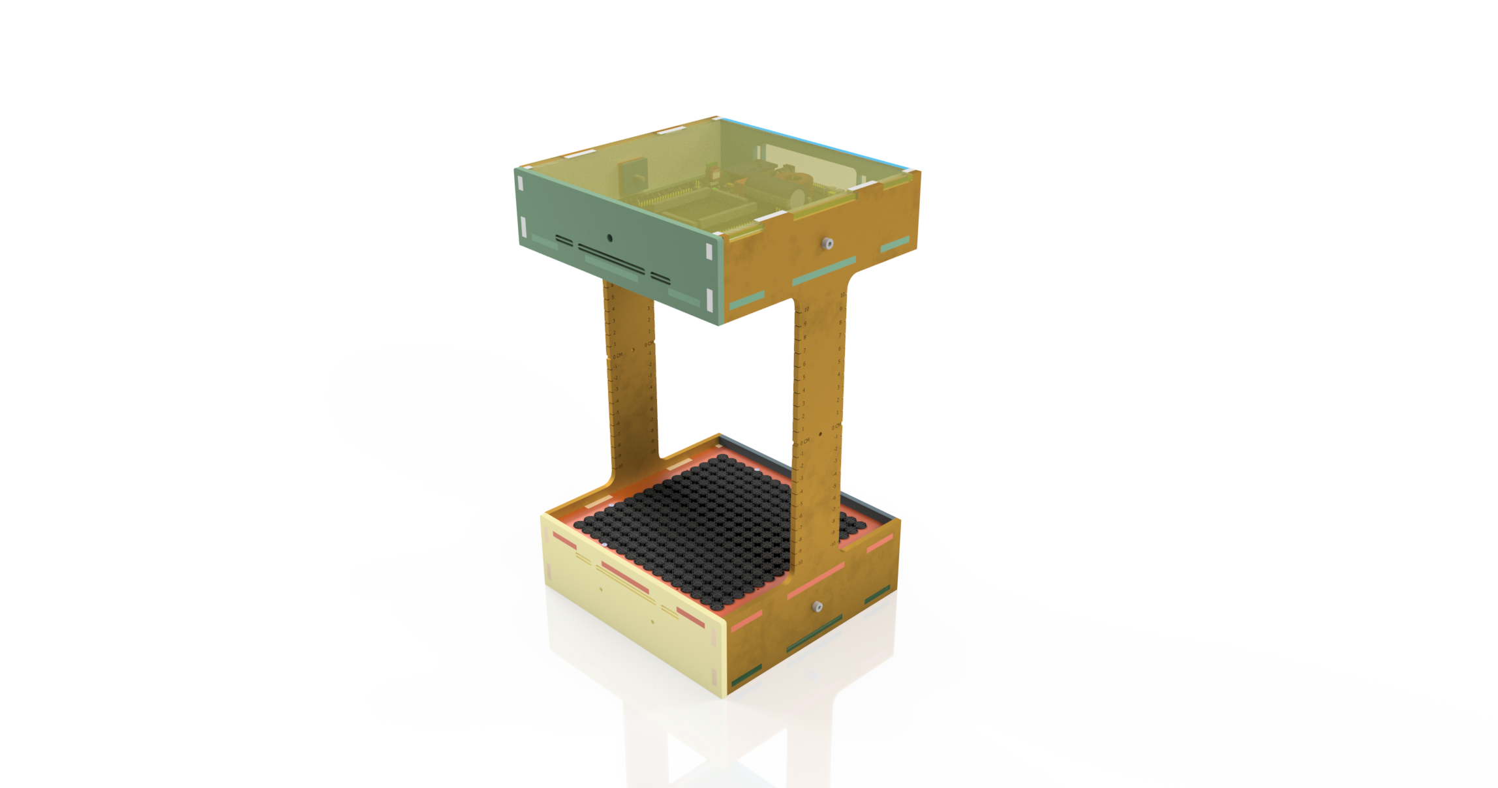

Figure 80 Completed Assembly

You should now have a completed setup.

Use our other guides on how to hook up the electronics and use the Particle Based Display.

Identifying our hardware by revisions

# Identifying the Controller Board (Formerly *Daughterboard*)

## Quick Glance of Controllers

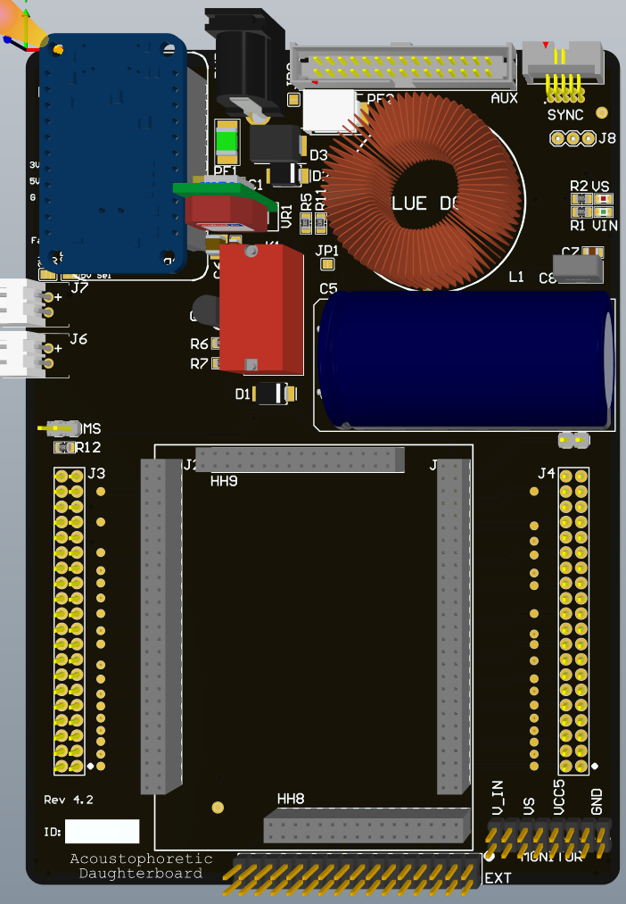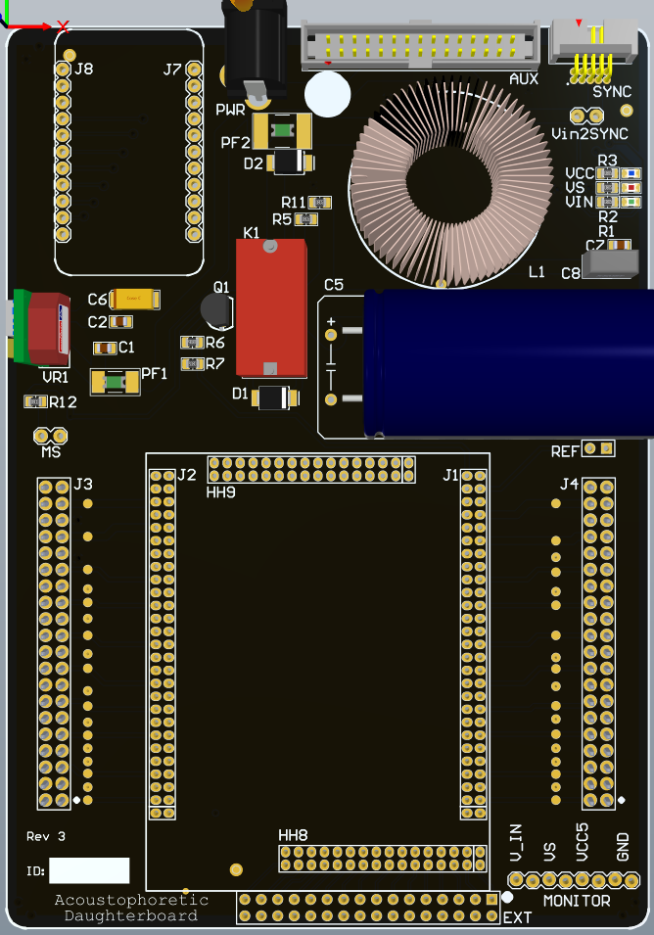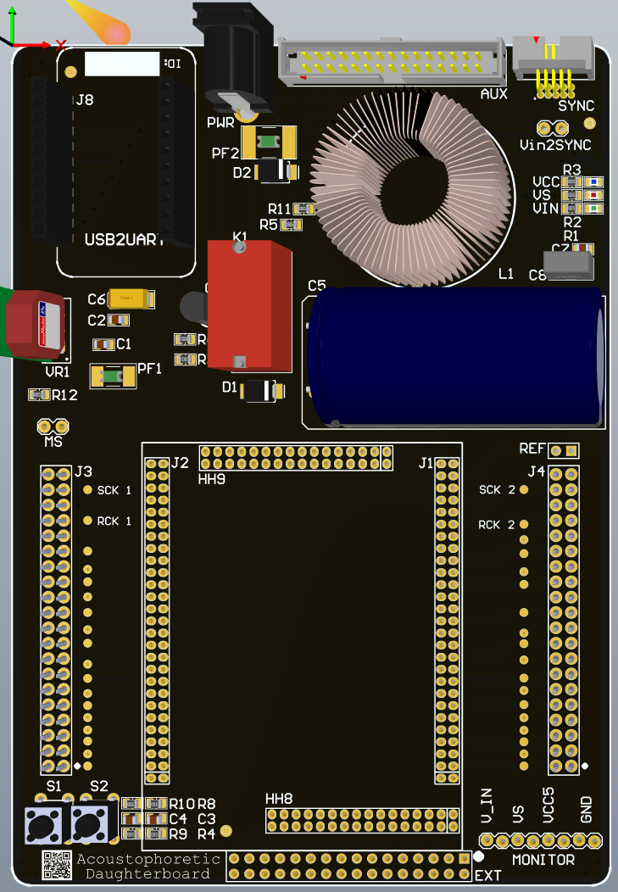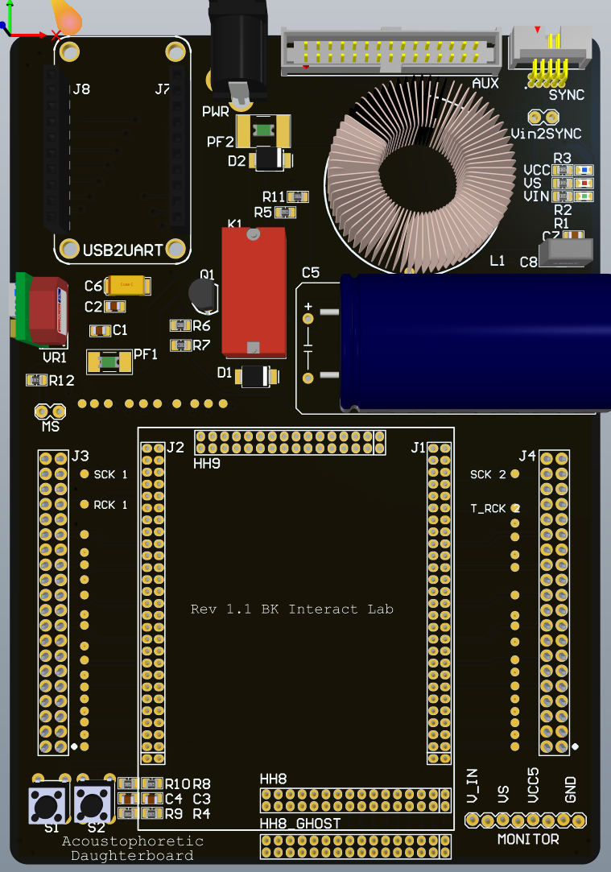We Have gone through four controller revisions:

Figure Reading like a comic book (top left to bottom Right): Rev 1, 2, 3, and 4

## Controller Board Change Log

Never assume cross compatibility when swapping out boards and sub-boards before checking the change log below.

|  |  |  |
| --- | --- | --- |
| **Revision** | **Quantity** | **Change Notes** |
| 1 | 10 | Initial Design.  No REF header.  No Thermal relief, difficult to solder to power planes.  No ID pane.  ‘HH8’ is 2mm pitch.  Does not pull out all USB bridge pins to FPGA so some boards may have mod wires connecting more bridges between the two.  Contains test points on USB bridge to FPGA pins. |
| 2 | 25 | **This and future revisions require different pin mapping in the FPGA Firmware – i.e. Rev 2+ have the same FPGA pin mapping and are different to the pin mapping for Rev 1**  QR Code added, now defunct.  Added thermal relief.  All layer tracks and pads physically identical to rev 1 except changes highlighted.  Added REF header.  SYNC Header re-routed to different FPGA pins.  USB Bridge is now fully pulled out to the FPGA.  ‘HH8’ is now ‘EXT’ and header is now 2.54mm pitch.  Removed USB bridge to FPGA test points.  Added MATCH ORIENTATION on the bottom of the board.  Added serial ID pane on the top left under the USB bridge |
| 3 | 20 | **This and future versions require the USB C bridge version which has an extra pin on each row, you can still use USB Micro B bridges, but you MUST position the bridge to populate all pins except the top two labelled 3V and GND.**  USB C bridge added **but with a fault in the design –** **You must snip the 5V leg on the USB bridge as the 5V pin on the PCB is erroneously shorted to ground.**  Shifted REF slightly lower out of the way of the large capacitor and labelled it REF.  Removed Buttons and QR code on the bottom left. *The removal of the buttons should be reflected in the pin map for the HDL to remove debug_btn 1 and 2.*  Vin pin on MONITOR can carry more current.  Added UCL Logo to the rear.  Added Rev number on the bottom left.  Moved the Serial ID pane on the bottom left.  *All other tracks and pads are otherwise identical to the previous Rev 2.* |
| 4 | 20 | Added polyfuse’s to USB bridge 5 V, Vin and 5 V regulator.  Newest revisions change MS to SS, as that is the behavior with the addition of the jumper  Added series diode to Vin to drop approximately 1 V so we can safely use 24 V power supplies.  Pull out 3V from the USB Bridge, maximum 150 mA draw allowed.  Pull out 5V from USB bridge passing through a solder bridge.  Removed ‘Vin2SYNC’ power bridge jumper.  Solder bridge to select 5V source for 5V rail to shift registers and other components, source from Vbus from the USB Bridge (500 mA max draw) or the 5 V on-board generator VR1  Added fan headers: Rev 4 and rev 4.2 swap from incorrect to correct polarity pins  Fan headers can be powered from 3V or 5V via solder bridge.  J5 pulls out USB Bridge 5V and 3V to 2.54mm header.  Added 2.54mm header that accesses the input and output of the LC filter, to use it you must remove the bridges on JP1 and JP2.  Removing JP1 allows you to use a different Vs source via the relay K1, bridging JP1 sends the output of the LC filter to the relay.  JP2 bridges the fused Vin from the PWR port. Removing JP2 allows an alternative Vin at J8.  Added USB Bridge pinout on the silkscreen.  Re-arranged placement power stage on PCB, not schematic.  Removed VCC LED since the FPGA has a VCC LED.  MONITOR is now a 2x8 header, this allows more probe points, also more current draw if desired.  Physically, the USB bridge to FPGA, FPGA to AUX, FPGA to motherboard coupling headers, and the FPGA to the SYNC port remain identical. |

# Close-Up View of the Controller Board Revisions

## Rev 1



Figure 82 Rev 1

## Rev 2



Figure 83 Rev 2, Note the QR code and buttons on the bottom left, the ID pane on the top left.

## Rev 3



Figure 84 Rev 3, note the bottom left ID pane and 'Rev 3.3'. Note: Physical hardware may show Rev 3 not Rev 3.3

## Rev 4



Figure 85 Rev 4.2 Note physical boards may be Rev 4 not 4.2. Note the Rev number on the bottom left, the Fan headers on the left, and the double row breakouts on the bottom

# Array Board Identification (formerly *Motherboard*)

## Quick Glance at Array Board

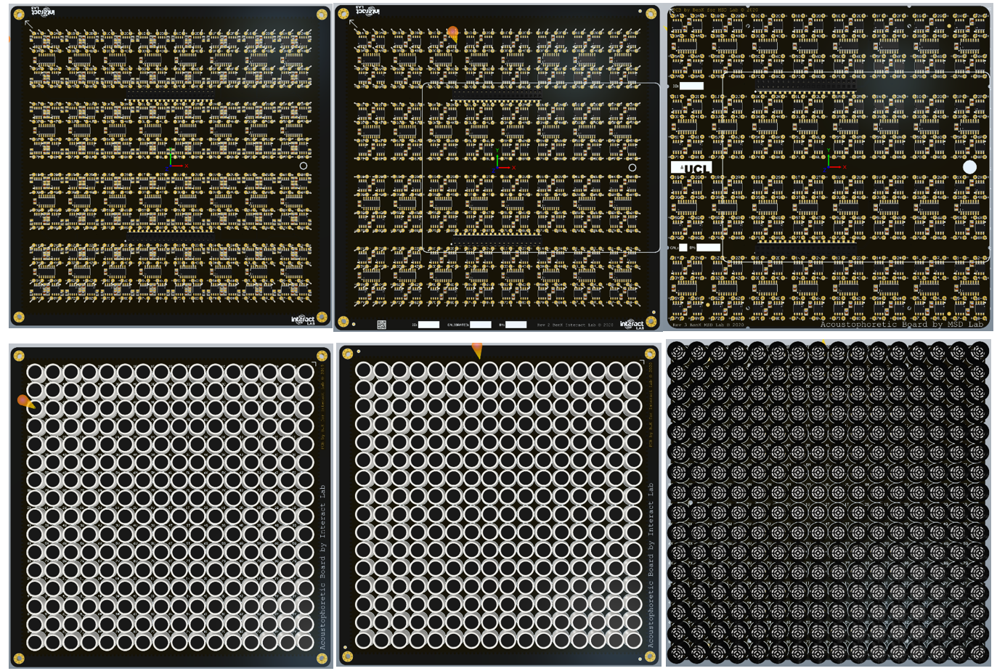We have three revisions of the Array Board; the two IO headers remain pin compatible with all controller boards.

Figure From Left to Right: Rev 1, 2, and 3

## Controller Board Change Log

|  |  |  |
| --- | --- | --- |
| **Rev** | **Quantity** | **Changelog** |
| 1 | 10 | Initial board.  No rev ID. |
| 2 | 20 | Added QR Code.  Added ID, Calibrator name and calibration date panes  Mistakenly removed transducer designators on the transducer side of the board (bottom).  Added outline of Controller board to help orientation.  Removed bypass capacitors for the amplifier (MOSFET drivers) – not needed and may degrade performance.  Minor track clean-up.  Major re-routing to the SHCP and STCP clocks for the shift registers, cleaning up routing, reducing length and number of bends, and reduction of number of vias and layers it crosses all improving signal integrity.  Rev ID on the bottom of the board. |
| 3 | 20 | **This board is electrically compatible with all other hardware, however mechanically it requires an adapter to fit into old cases, or a new case to fit the newly placed screw holes.**  Removed via stitching around the board which would normally help reduce EMI into and out of the board.  Removed defunct QR code.  Added UCL logo.  Added a hole to add a standoff under the controller to stabilize it when pushing down on the controller.  Label panes moved to the left.  Rev ID added to the bottom of the board.  Trimmed all four edges of the board.  Major rerouting required to move the two IO headers left so that the edge of the controller board lines up with the edge of the new trimmed board as well as the previous revision array boards.  Added four screw holes inside the board.  Added four half screw holes on the edge of the board.  STCP remains identical to the previous revision.  SHCP remains mostly identical to the previous revision.  Top layer: mostly identical to previous revision except for nets connecting to the IO headers.  Inner power and ground planes are identical to previous revisions.  Bottom layer remains almost entirely identical. |

### A screenshot of a computer Description automatically generated with medium confidenceRev 1

Figure 87 Rev 1, note we usually ID and place a sticker with the ID on the right side of this side of the board

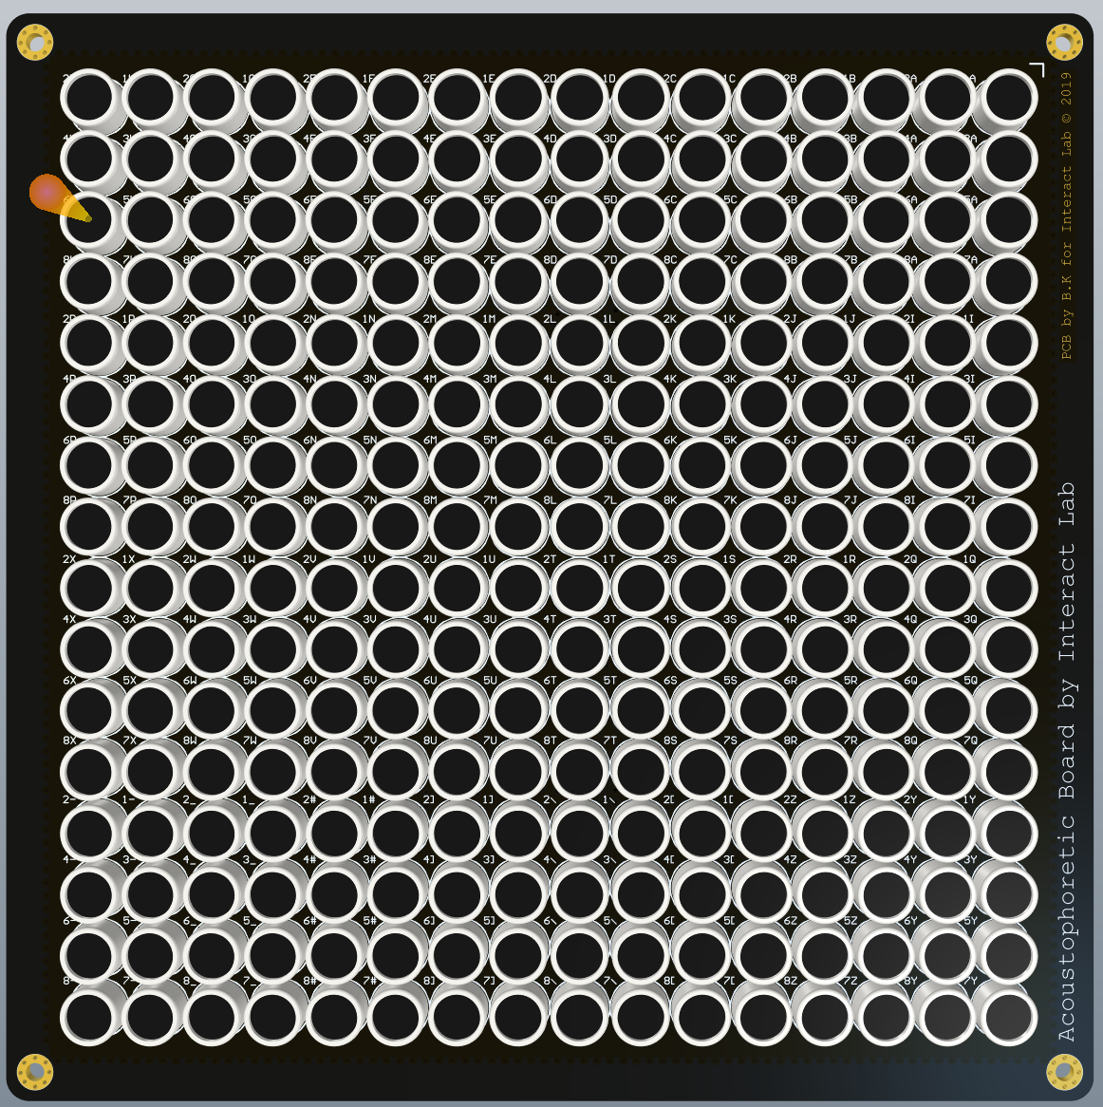

Figure 88 array side of rev, note the silkscreen text and year 2019

## A screenshot of a computer Description automatically generated with medium confidenceRev 2

Figure 89 rev 2, note the interact Lab logos, QR code and info panes on the bottom

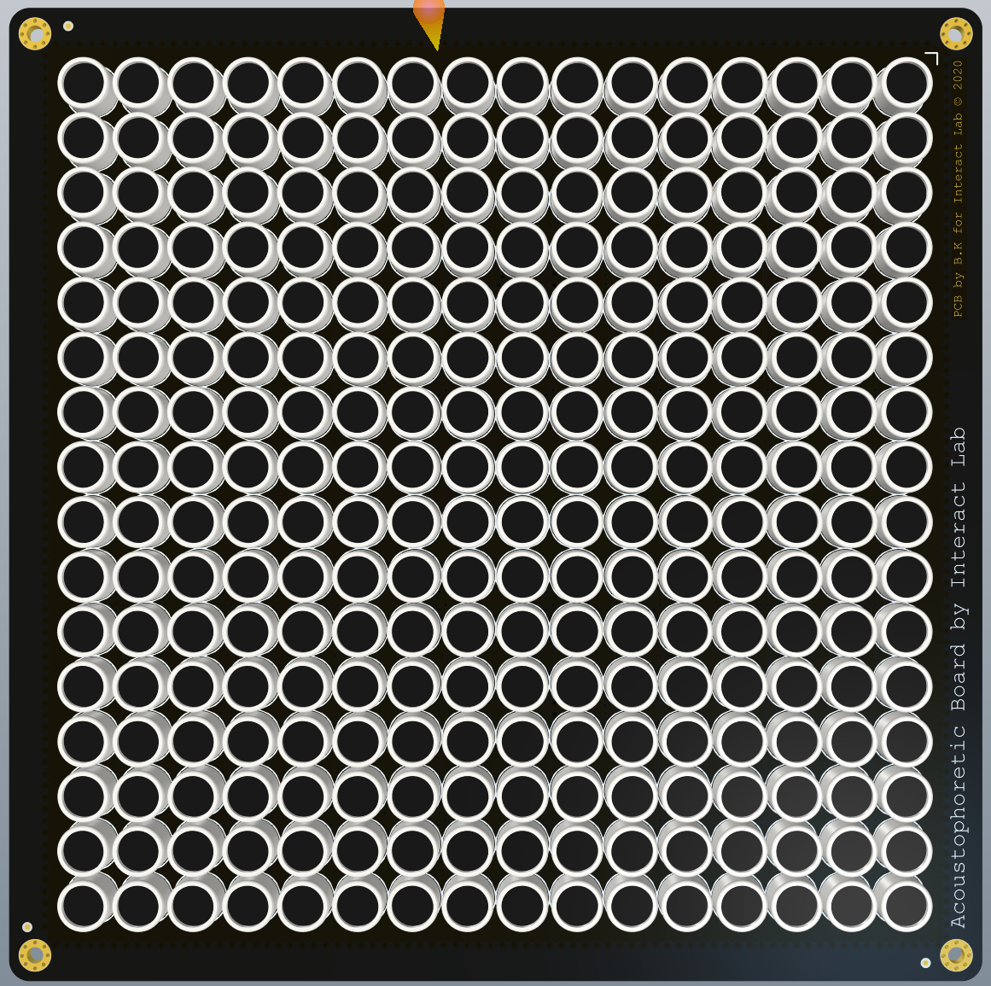

Figure 90 identical to rev 1 other than the date of 2020 instead of 2019 and the lack of silkscreen transducer labels

## A screen shot of a computer Description automatically generated with low confidenceRev 3

Figure 91 a major revision that truncates the edges, note the UCL logo

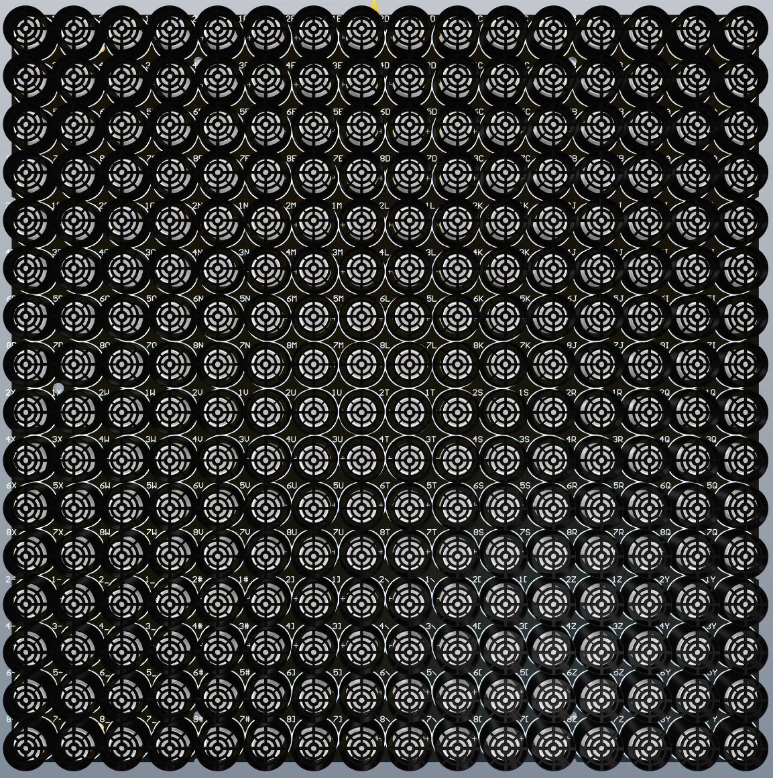

Figure 92 Note the return of the transducer labels